Name:_________________________________ Pd:____ Date:________________
Keys to Success for the Science Final Exam!
(aka- 2nd Quarter Exam Study Guide)
7.E.1.1 - Compare the composition, properties and structure of Earth's atmosphere to include: mixtures of gases and differences in temperature and pressure within layers.
- Explain the temperature differences in each layer of the atmosphere.

- Create a pie chart that represents the main components (w/ percentages) of Earth’s atmosphere.

- Explain the differences in air pressure in each layer of the atmosphere. How does relate to density? In the boxes below, show an example of air that is less dense and air that is more dense.
Less Dense

More

More Dense

More

- Create line graph that shows the relationship between altitude and temperature in the troposphere. Remember, temperature is on the “y-axis” and altitude is on the “x-axis.” (Hint… As altitude ______; temperature _________ in the troposphere)

7.E.1.2 Explain how the cycling of water in and out of the atmosphere and atmospheric conditions relate to the weather patterns on Earth.
- Define the term water cycle?

- When condensation occurs, the water vapor in the air cools changing back into liquid form. Give a real-world example of where you have seen condensation (not the creation of clouds).

- True or False: The water we drink today is the same water that dinosaurs drank. JUSTIFY your answer.

7.E.1.3 Explain the relationship between the movements of air masses; high and low pressure systems, and frontal boundaries to storms.
- What are the major air masses AND what type of air do they bring?

- Explain the conditions that are ideal for hurricane formation.

- Define and create a drawing of the following…

COLD FRONT: | WARM FRONT:

7.E.1.4 Predict weather conditions and patterns based on information obtained from: data, weather tools, weather maps, cloud types and shapes.
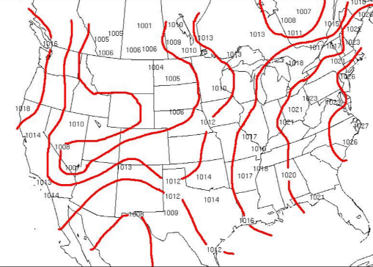
- Explain what the map to the left represents.

- Explain what type of weather is expected if…
  - the barometric pressure is falling

  - The barometric pressure is rising

- Analyze the data below for City Y. Explain what has most likely occurred in the area.
Day and Time | Friday at 7:00am | Saturday at 4:00pm
Temperature | 60ºF | 75ºF
Pressure | 27.35 in. | 30.22 in.
Skies | Partly Cloudy | Clear Skies; Sunny

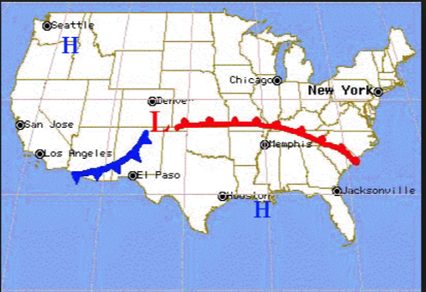
- Explain the weather conditions for the next few days for the following areas…

  - New York (if the current temperature is 65ºF and cloudy)

  - El Paso (if the current conditions are clear skies and 80ºF).

  - Seattle (if the current conditions are rainy and 65ºF)

7.E.1.5 Explain the influence of convection, global winds and the jet stream on weather and climatic conditions.
- Define the Coriolis Effect AND create a diagram that explains its effect of the Northern & Southern Hemispheres.

- Define and create a diagram of the following…
Sea Breeze: | Land Breeze:

- Winds are caused by…

- What major wind belt affects weather over the continental United States? Explain how this wind belt pushes the air over the U.S.

- Explain why a flight from Raleigh, NC to Los Angeles, California would take longer than the return flight from Los, Angeles to Raleigh.

7.E.1.6 Conclude that the good health of humans requires: monitoring the atmosphere, maintaining air quality and stewardship.

- Define the term environmental steward.

- How can students at DMS help with the issue of pollution?

- Why is it important for the United States to monitor air pollution levels in other countries?

- Explain what effect would occur if there were an INCREASE in ground level ozone AND a DECREASE in upper atmosphere ozone.

- Create a drawing that shows the main layers AND pauses of the atmosphere, in order, starting at Earth. Identify which layer the following would be found…
  - Space Shuttle
  - Meteors
  - Water Vapor
  - Airplane
  - Ozone Layer
  - Weather/Clouds
  - Describe what happens to pressure and density as you increase in altitude within the layers of the atmosphere.

- Label each major wind belt system. If an explosion occurred in Los Angeles, California, which wind belt system would be responsible for carrying pollutants from the explosion? Over the next several weeks, which continent(s)/countries would most likely be affected by this explosion? Justify your reasoning.

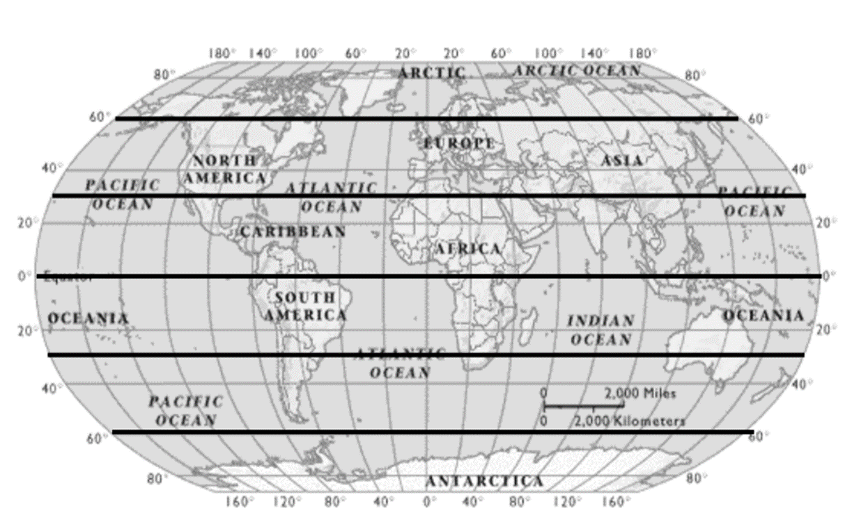

- Create a diagram that shows the cycling of water in and out of the atmosphere. Make sure to include the following processes…
  - Infiltration
  - Evaporation
  - Transpiration
  - Runoff
  - Condensation
  - Groundwater
  - Precipitation
  - Arrows showing the direction of movement through the cycle

