**Video Notes # 2: Altitude, Temperature, Air Pressure, Density, Ozone, Greenhouse Effect and Climate Change**

**I can define Altitude, Air pressure, temperature and density**

**______________________________**: the height of anything above a reference level, especially above sea level on earth. Example: As a plane takes off, it’s altitude is _____________________ as it gets higher.

**C:\Documents and Settings\Administrator\Local Settings\Temporary Internet Files\Content.IE5\EH9Y3E5W\MC900070966[1].wmf______________________________**: the force exerted by air, whether compressed or unconfined, on any surface in contact with it. Example: When you blow up a balloon, you are increasing the amount of air pressure inside the balloon causing it to expand.

**______________________________:** a measure of the warmth or coldness of an object or substance with reference to some standard value.

**Density:** mass divided by volume. It is the measure how much mass there is per volume. The more dense something is, the heavier it is

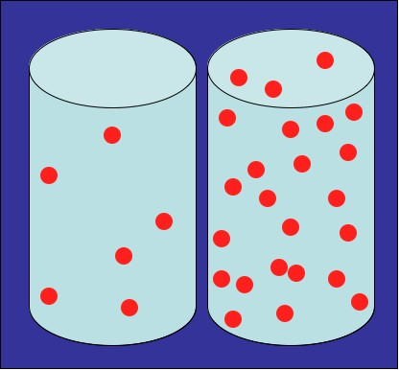 Low density high density

**I can describe how altitude affects air pressure and temperature**

**Altitude and Air Pressure**

* As ________________ __________________________, __________________________ _____________________decreases.

**Altitude and Temperature**

* As altitude increases in the ______________________temperatures _______________________
* As _______________________ increases in the Stratosphere _____________________ increases
* As altitude increases in the ________________________________temperature______________________
* As altitude increases in the __________________________________ temperature ________________________

**I can define ozone and identify “good” and “bad” ozone**

___________________________________ (O3) gas that occurs in Earth’s upper atmosphere and at ground level.

**Good Ozone:**

* A thin layer in the ______________________ that protects us from the _______________
* Blocks ______________________________________________________ from reaching Earth’s surface.
* Makes up 90% of ozone

**Bad Ozone:**

* Found close to ___________________________ of Earth, in the ______________________.
* Makes up 10% of ozone.
* Main ingredient is urban ____________________________________________________
* Air pollutant that is _____________________________________________ and it damages crops, trees and other vegetation.

**What happens if we have more UV Rays…**

* more cases of ______________________________
* increase in melanoma
* impaired immune systems
* Cataracts
* Damage to sensitive __________________________
* reduce __________________
* _________________________ in phytoplankton (base of the food chain for ocean animals)

**I can describe the Greenhouse Effect**

* **Greenhouse Effect**: The trapping of heat near Earth’s surface by greenhouse gases (Carbon Dioxide, Methane) that form a “blanket” around the Earth
* Without the greenhouse effect, Earth would be much colder—about 33 Celsius degrees colder, on average. All of Earth’s water would be frozen!

**I can describe climate change and discuss how to be an environmental steward**

**______________________________________**: is an average ________________________________________________ of the atmosphere near the Earth's surface and in the troposphere, which can contribute to changes in global climate patterns

* Climate Change can occur from a variety of causes, both ________________ and _______________ included

**Why does Climate Change affect us?**

* Glaciers, permafrost and sea ice are disappearing
* Sea levels are rising, seasons changing and extreme weather is becoming more extreme
* Could lead to more ___________________, ________________________, ________________________

**What can I do to help?**

**________________________________:** is someone who _______________________ the environment through ___________________________, conservation, regeneration, and restoration.