Name:___________________ Per___
Altitude, Air Pressure & Temperature
Altitude: _________________________________________________________________________________
Air Pressure: _____________________________________________________________________________
Density: _________________________________________________________________________________
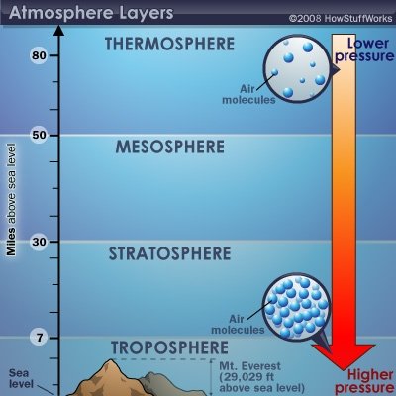
Xl;kxcx Look at the air molecules in the bubble at lower and jjsjdjsdsjdjsdjsjdsdjksjdskjdskjdskjdkjdjdskjdskjdkdkj higher air pressures. How do you think density and air pressure pressure are related?
__________________________________________________________________________________________
__________________________________________________________________________________________
__________________________________________________________________________________________
__________________________________________________________________________________________
__________________________________________________________________________________________
___________________________________________________________________________________________
Using the illustration of the mountain below, answer the following questions:
- Where is altitude the greatest? _________
- Where is air pressure the greatest? __________
- Where does air have less mass? _________
- Where are the oxygen molecules the farthest apart? _______
- Where is the temperature the coldest? _______
- Where would air seem the heaviest? ________
- Where might a hiker have the most difficulty breathing? _____
- If air pressure is constantly pushing down, why doesn’t it crush things such as a empty can?
- As you move toward sea level, from B to A, what will happen to the air pressure and the air temperature?______
A
B
Sea Level

Look at the following data on air pressure and plot a graph to show the relationship between altitude and air pressure.
Air pressure vs Altitude data table
Altitude (M) | 0 | 1000 | 2000 | 3000 | 4000 | 5000 | 6000 | 7000 | 8000 | 9000 | 10000
Air Pressure  (PSI) | 15 | 13 | 12 | 10 | 9 | 8 | 7 | 6 | 5 | 4 | 4

______________________________________________

What is the relationship between altitude and air pressure? __________________________________________
_________________________________________________________________________________________

