Name__________________________ Per_______ Due: _________
The Atmosphere
Subunit: Atmospheric composition and layers
Objective 7.e.1.1 ___________________ the ________________, properties and structure of Earth's _____________________ to include: mixtures of gases and differences in temperature and pressure within layers.
What is atmosphere, and what are atmospheric gasses?
Atmosphere: a __________________ ____________________ of air or (_________________) surrounding the earth. This air is made up of _________________________ (78%), _________________________________ (21%), _______________________ (less than 1%), _________________________ (less than 1%) and others.
__________________ are also a part of the atmosphere. The atmosphere is ___________________ to our _______________________ and _________________ on earth.
What is the most abundant gas in our atmosphere? _____________________________________.
To remember the composition of the gasses in the atmosphere.
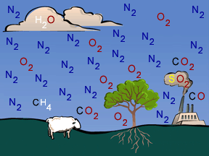
Remember! Never open canned worms
Never (___________________)
Open (____________________)
Canned (Carbon Dioxide)
Worms (Water vapor)

How does earth’s atmosphere compare to others ________________________________________________________________________________________________________________________________________________________
How is the atmosphere divided?
The atmosphere is divided into _____________ distinct layers.
From closest to earth the layers are __________________________, _________________________
_____________________________, ______________________.
The outermost layer is known as the _________________________ and extends beyond the thermosphere to include space. We do _____________ know where the exosphere ends. Each layer is separated by a line known as a ________________.
To remember the layers of the atmosphere Remember! The Sand Man Took Elmo
______________ (Troposphere)
______________ (Stratosphere)
______________ (Mesosphere)
______________ (Thermosphere)
______________ (Exosphere)
Label the Layers and pauses below.
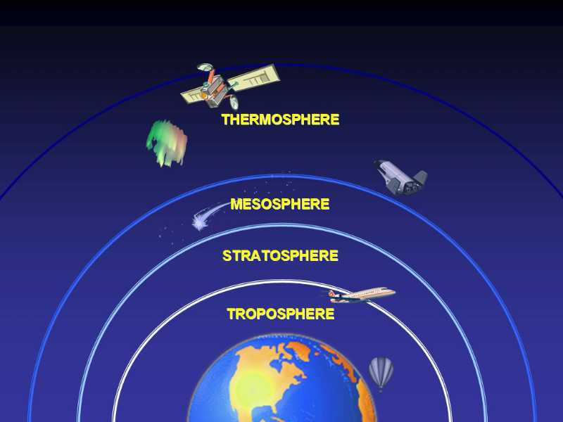
The ______________________. This is the ___________________ level of the atmosphere, it contains __________________ and buildings. All ___________________ occurs in this layer. It extends to about _____________ above _________________. The temperature ranges from about ______⁰C to _________⁰C. This layer ends at the _______________________. Bad ozone is found in this layer.
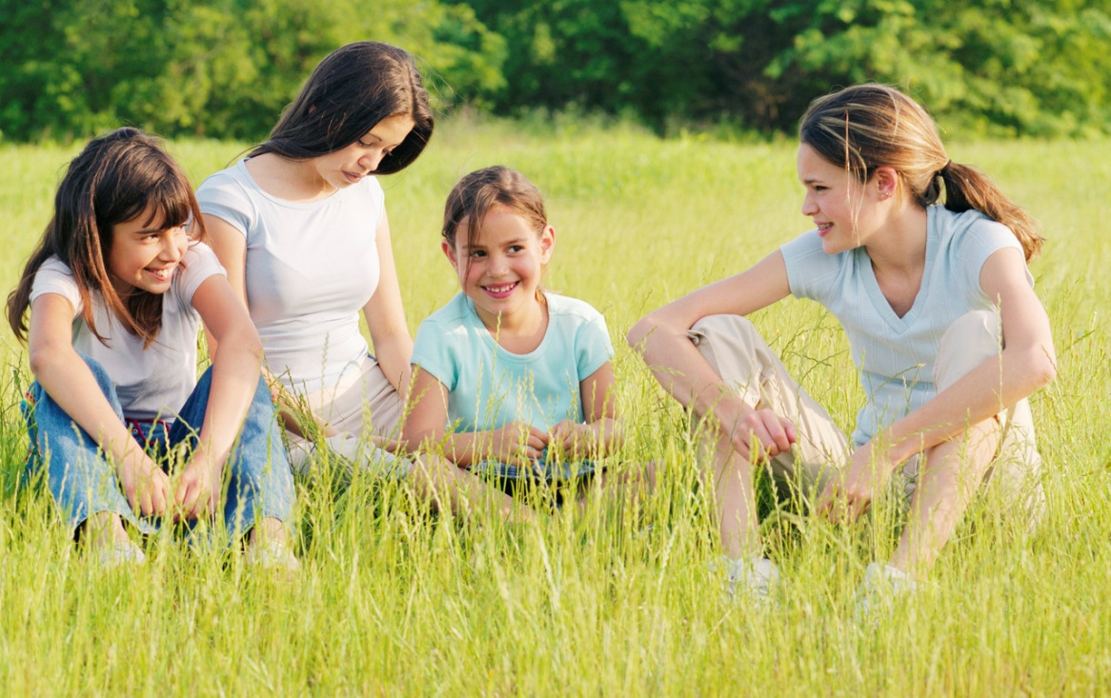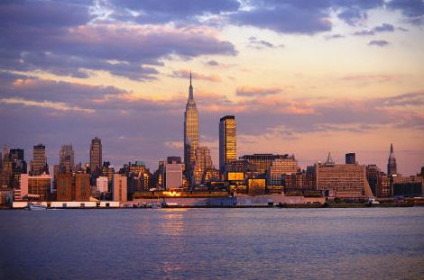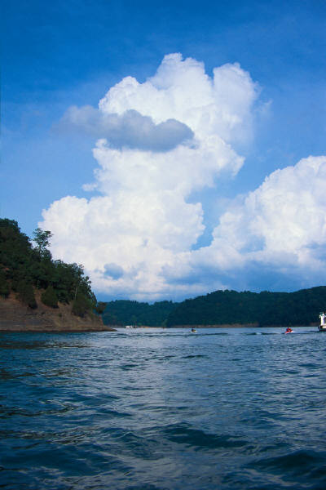
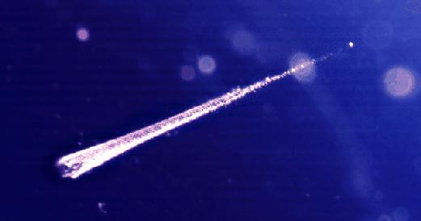
The __________________Contains: ____________ (The good ozone) layer which is a ______________________layer that absorbs ___________ light from the sun. Flying _________, and _______________ Balloons. Here you are ______________ the _________________ only the largest thunderstorms reach up here. This layer ends at the ______________________.
The ___________________ “Meso” means _______________ it is the middle layer! Outer parts of Mesosphere are the _______________________ parts of the entire Atmosphere. Meteors burn up in this level, often giving off the look of a shooting star. The mesosphere is one of Earth’s __________________ layers. It ends at the _______________________.

The _______________________- Air is very _____________- Low Density. _________________ Layer (1800 C) due to the sun’s heat. The Ionosphere is found within this layer.________________ waves bounce off ions in this layer. Aurora Borealis-_________________ _________________ glow from ions and sunlight. The layer ends at the ________________________.

The ____________________________Begins at the thermopause. Some ________________ orbit here. For example _______________ and ____________________ signals are sent this high
Where does it end? There is no clear line that says okay you are in space now. We don’t know!

