Name_____________________________ Pd: ____ OBJECTIVE: 7.P.1.2
Balanced & Unbalanced Forces
Essential Question: How do balanced and unbalanced forces affect an object's motion?
What is Inertia?
_________________: the __________________ of any physical object to any _________________ in its state of motion, including changes to its speed and direction.
- Inertia tells us that we need a _______________ to get an object to move or stop an object from moving.
What is a Force?
In science, a force is a ___________________ or a ___________________
- All forces have two properties: _______________________and ______________________
  - A ________________ (N) is the ______________ that describes the _____________ of a force.
Example:
•The student is pushing down on the chair, but the chair does not move.
•The floor is balancing the force by pushing on the chair.
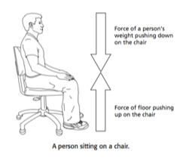
The student is _________________ down on the chair, but the chair does not move.
•The floor is _________________ the force by pushing on the chair.

Combining Forces
More than one ____________________ often acts on an ________________________
- When all the forces acting on an object are ___________ together, you determine the ______________ on the object.
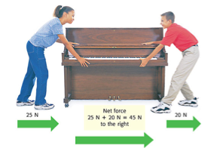
- An object with a net force _________________________ on it will change its state of ____________.
Forces in the Same Direction
When _______________ are applied in the __________ direction, they are _____________ to determine the ________ of the net force.

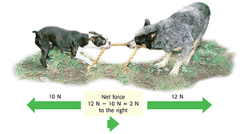
Forces in Different Directions
When two forces act in ________________ directions, you _____________ the smaller force from the larger force to determine the ________________________.
- The net force will be in the ________________________ as the __________________ force.

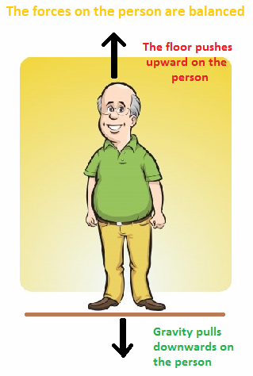

Balanced Forces
When the forces on an object __________________ a _____________ of _________, the forces are ______________.
•There is ____________________ in the ___________ of the object.

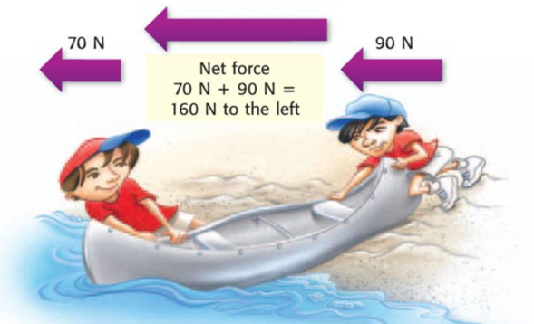

Unbalanced Forces
When the ______________ on an object is ________________, the forces on the object are _______________________.
Unbalanced forces produce a _______________________________ of an object.
PRACTICE
1. 2. Net Force:_______________
350N
ç
ç
200N
Net Force: ________________ 10N
ç

30N
75N 4,
ç
ç
ç
3.
ç
ç
75N 150N 10N
Net Force:__________________ Net Force:_______
Gravity
Gravity is the force of ____________________ between matter.
Gravity depends on: ________________ and __________________
Mass and Gravity
The _________________ an object the more it can _____________objects to itself.
- For example, the Sun has a larger gravitational effect than the Earth.
Distance and Gravity
The __________________ objects get from one another, the _______ gravitational attraction can be found.
Magnets
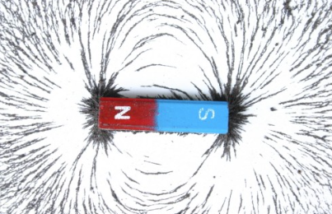
A ______________________: an object with a north and south pole that produces a ___________________ and exerts a __________________________.
A ____________________________ is the force field that surrounds the magnet.
A ____________________________ can cause objects to _______________ or _______________ without needing to touch the magnet!
How do magnets affect motion?
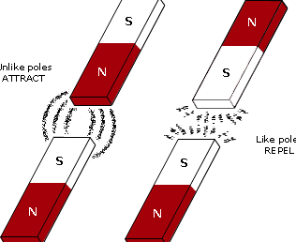
_________ poles will ___________ or move ____________ from one another.

____________ poles will ___________ or move _______________ one another.

Example:
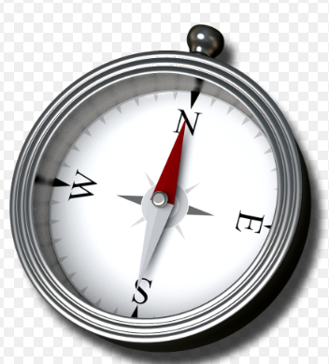
A compass uses the Earth’s magnetic field and magnets to help a person determine direction. The magnet’s poles will line up with the Earth’s north magnetic pole and south magnetic pole.

