Name___________________________________________________ Date_______________________
Third Quarter Cells Exam Review
- What organelle do plant-like protists contain that make them like plants?
- What does autotropic mean?
- What provides half of the world’s oxygen supply?
- How do protozoans behave like animals?
- What does heterotrophic mean?
- How are protozoans organized or grouped?
- How do sporozoa reproduce?
- Are fungus-like protists heterotrophs or autotrophs? Explain.
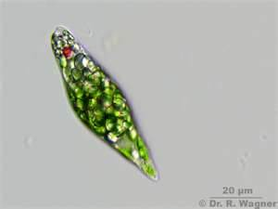
- Give at least three examples of fungus-like protists.
- How does Figure 1 move?
- How does Figure 2 move?
Figure 1
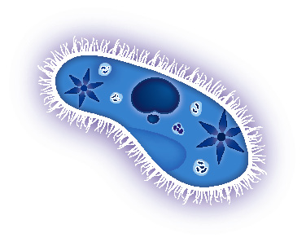
- How does Figure 3 move?
- How does Figure 4 move?
- What is the protist in Figure 1?
- What is the protist in Figure 2?
Figure 2
- What is the protist in Figure 3?
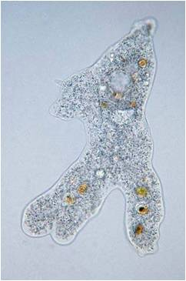
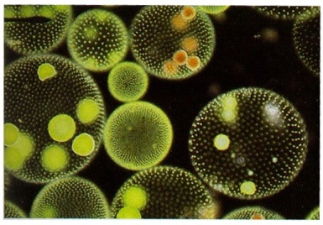
- What is the protist in Figure 4?
Figure 4
Figure 3
- What is the function of a lysosome?
- What is the function of a cell membrane?
- What is the function of a cell wall?
- What is the function of the mitochondria?
- What is the function of the nucleus?
- Which cell has one large vacuole?
- Which organelles are found only in plant cells and not an animal cell?
- Which organelle turns sunlight into glucose?
- What are groups of specialized cells working together form?
- What is a collection of tissues joined together that carry out a specific function?
- What is the correct order of hierarchy in an organism?

- Compare and contrast animal cells and plant cells. (you may draw a Venn diagram in place of writing sentences)

- Describe and give examples of plant-like, animal-like, and fungus-like protists
  - Include and underline the following words and provide examples of each type of protist.
    - Heterotroph
    - Autotroph
    - Eukaryotic
    - Unicellular
    - multicellular
    - Algae
    - Protozoan
    - Decomposers

- Explain why Euglenas and Volvox are “special” protists. Include what type of protist they each are, how they obtain their food, what makes them special, how they move, and draw a picture of each.

- Write and analogy for each of the organelles and explain your analogy (1 sentence for each organelle)
  - Nucleus
  - Mitochondria
  - Cell Membrane
  - Chloroplast
  - Vacuole

