Cell Project: Due Friday March 3rd
Option 1: Write an International children’s book
Write a CHILDREN’S book about cell parts and their functions. It should be interesting and EASY TO UNDERSTAND. This is a story, not just stating the facts. It should be illustrated with appropriate illustrations that describe what is happening on each page of the story. Your story must be set in another country and should include landmarks that let us know what country it is.
You can choose to do either the animal cell or the plant cell. The following organelles must be included:

- Cell Membrane
- Nucleus
- Ribosomes
- Golgi Body
- Endoplasmic Reticulum
- Vacuole
- Mitochondria
- Lysosomes (animal only)
- Chloroplasts (plant only)
- Cell Wall (plant only)

Option 2: Create an International Paper Slide Video
Create a paper slide video about cell parts and their functions. It should be interesting and EASY TO UNDERSTAND. This is a story, not just stating the facts. It should be illustrated with appropriate illustrations that describe what is happening on each slide of the story. Your story must be set in another country and should include landmarks that let us know what country it is. You can choose to do either the animal cell or the plant cell. The following organelles must be included:

- Cell Membrane
- Nucleus
- Ribosomes
- Golgi Body
- Endoplasmic Reticulum
- Vacuole
- Mitochondria
- Lysosomes (animal only)
- Chloroplasts (plant only)
- Cell Wall (plant only)

Option 3: Using your own materials create a model of the cell.
The model should be Large all the organelles must be presented and the materials used must not be perishable. (You must find your own materials if you choose this option). You must also make a poster that explains what each organelle does and write an analogy for each part of the cell. Must be able to explain why your analogy makes sense.

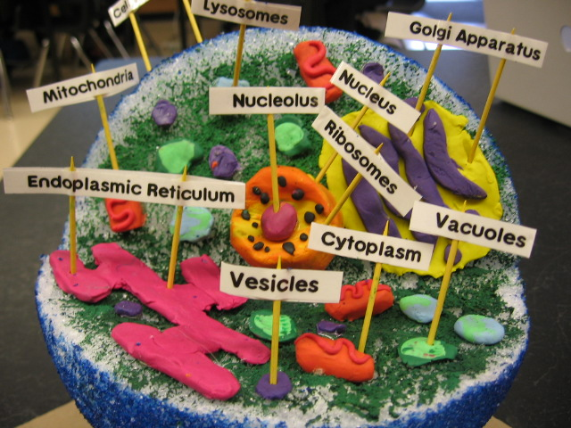
Grading: See attached rubric
Name: __________________________________________________________
Cell Project Rubric: 1 point each
Organelle | Used in story/video/Analogy | Function explained correctly | For models  Analogy | For Models  Physical representation
Cell Membrane
Nucleus
Ribosomes
Golgi Body
ER
Vacuole
Mitochondria
Lysosomes (animal)
Chloroplasts/Cell Wall (plant)
Paper Slide Video:
Appropriate Illustrations 6 points _____________
Tells a story, doesn’t just list the organelles 4 points _____________
Neatness 2 points _____________
Smooth transitions between slides 2 points _____________
Performance – Video (loud, clear) 6 points _____________
Easy to understand 4 points _____________
Children’s book/ Model :
Appropriate Illustrations 6 points _____________
Tells a story, doesn’t just list the organelles 4 points _____________
Neatness 2 points _____________
Spelling/Grammar 2 points _____________
Performance (loud, clear) 6 points _____________
Easy to understand 4 points _____________ Final Grade: ________/_________

