Station 1 and 2 – Cells Alive
Cells Alive Webquest URL: www.cellsalive.com
Animal Cell Model - For this model, you will need to click on the various parts of the cell to go to a screen that tells you about the parts. Answers to the following questions are found there.
1. What do mitochondria do?  2. How big are mitochondria?  3. What does the Golgi Apparatus do?  4. What is the difference between smooth and rough ER?  5. Where is the nucleolus found?  6. What does the nucleolus do?  7. What does the cytoskeleton do?  8. Cytosol goes by what other name?  9. What is the function of the cytosol?  10. What is the function of the lysosome? | Sketch each of the following.  Mitochondria  Lysosome  Golgi Apparatus  Rough ER

Plant Cell Model - (you will need to return to the "Cell Biology" link to access this page, or hit your back button)

1. What other type of cell has a cell wall?  2. What makes the plant cells green?  3. In plant cells, what does the vacuole do? | Sketch the following  Chloroplast  Vacuole
Overview
For the chart below, place a check in the box if the cell has that component.

 | Plant | Animal
Chloroplast
Vacuole
Ribosome
Mitochondria
DNA
Endoplasmic Reticulum
Cell Wall
Golgi Apparatus

Station 3: Matching
Animal Cell
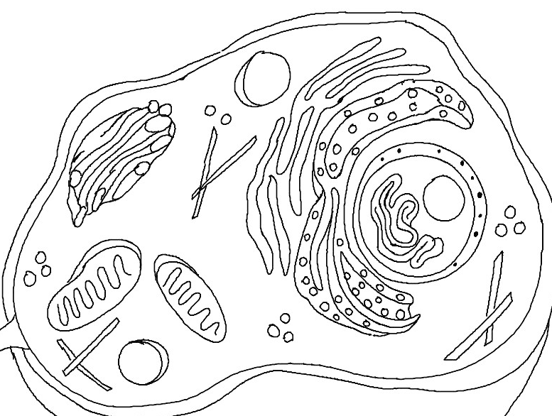

Plant Cell
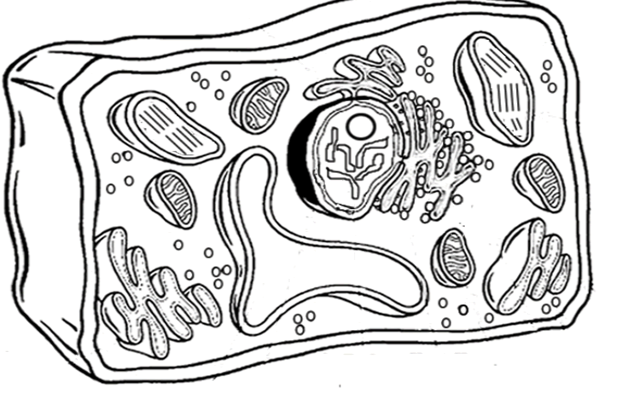
Station 4: Reading Comprehension
- List 4 things that LIVING THINGS do.
- How do cells get energy
- What happens during cellular respiration?
- How is energy stored?
- Where is DNA stored and what is controlled by the DNA?
- What is diffusion?
- What is osmosis?
- What is a plant cells extra layer called?
- What do the following organelles do?
  - Cytoplasm
  - Ribosomes
  - Golgi Appatatus
  - Vacuoles
  - Mitochondria
  - ER
  - Chloroplasts
Station 5: Organelle Matching part to function and Cell Riddles
Part 1: teacher signature _____________________
Part 2: Riddles

1.
2.
3.
4.
5.
6.
7.
8.

Station 6: Text Messaging Conversation:

P

Station 7: I Pad Minis – Cell Explorer
Golgi Apparatus: What would happen if the Golgi Bodies in the cell were destroyed? _____________________________________________________________________________
Cell Membrane (Plasma Membrane) Why is the plasma membrane critical to the survival of a cell? _______________________________________________________________________
Lysosomes: As a pilot, you should avoid lysosomes. Why?
_____________________________________________________________________________
Rough Endoplasmic Reticulum: What would happen if the rough ER in the cell were destroyed by Dr. Vial’s evil scheme?
_____________________________________________________________________________
Smooth Endoplasmic Reticulum: What would happen if the smooth ER in the cell were destroyed? _________________________________________________________________
Mitochondrion: What do mitochondria make? ____________________
What is ATP? _______________________________________________
To make ATP, mitochondria need to take in _____________________________________
Ribosomes: What would happen if the ribosomes in the cell were destroyed by Dr. Vial’s evil scheme?______________________________________________________________________
Nucleus: Why is the nucleus important? ____________________________________________
What is the main function of DNA? ________________________________________________
Nucleolus: What would happen if the nucleolus in the cell were destroyed by Dr. Vial’s evil scheme? ____________________________________________________________________

Why is each part of the cell important? ____________________________________________
____________________________________________________________________________
What type of cell are you exploring? How do you know? ______________________________
____________________________________________________________________________
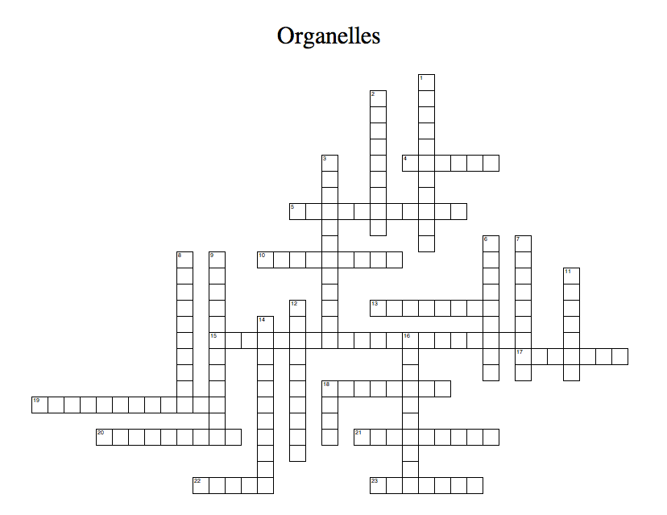
Station 8: Cells Crossword

ACROSS
4 | a protist that lives in a colony
5 | an organelle found in animal like protists that is used for digesting food
10 | the thick jelly like substance that fills the interior of the cell.
13 | the tough outer membrane of some protists like a euglena and paramecium that help the cell keep its shape
15 | the transportation system of the cell
17 | a protist that is both animal like and plant like
18 | an organelle found only in plant cells that is used for protection, support, and to keep the cell shape rigid.
19 | the organelle that provides energy for the cell
20 | an organelle found in animal cells used for digesting food
21 | a protist that can make its own food
22 | another name for plant like protists
23 | the organelle that controls cell function and reproduction
DOWN
1 | a protist that must hunt or gather its food
2 | another name for animal like protists
3 | an organelle found in plants and plant like protists that convert sunlight into glucose
6 | the organelle responsible for making ribosomes
7 | an organelle that makes proteins
8 | another name for fungus like protists
9 | the organelle responsible for determining what can come in and out of the cell. It also provides protection and support of the cell
11 | storage for water, food, wages, and enzymes
12 | The organelle that sends and receives proteins
14 | a vacuole only found in protists that removes excess water from the cell
16 | all cells that have a nucleus
18 | the smallest living thing

When you finish early at a station, complete the following: Write an analogy for each cell organelle. This means give me an example of something that would also serve the same function as the cell part.
Examples:
Mitochondria – provides energy for the cell
Analogy and explain why – Energy bar or energy drink provides energy for a person
Golgi Body – receives and sends proteins to other parts of the cell
Analogy and explain why: A post office sends and receives mail in a town
Nucleus Function:
Analogy and explain why:
Nucleolus Function:
Analogy and explain why:
Endoplasmic Reticulum function:
Analogy and explain why:
Lysosome function:
Analogy and explain why:
Chloroplast function:
Analogy and explain why:
Cell Wall function:
Analogy and explain why:
Cell Membrane function:
Analogy and explain why:
Ribosome function:
Analogy and explain why:

