Name:__________________ Per:___
Cell Theory, and Reproduction

Scientists that contributed to the Cell Theory

_________________________ –1665 discovered cells by looking at a slice of ____________ under the microscope. He described the cells as tiny boxes or honeycomb. He thought they only existed in plants and fungus.
_________________________: 1673 – observed _________________________ under a hand held microscope and discovered single-celled organisms. He called them “animalcules”. He also observed the blood cells from fish, birds, frogs, dogs, and humans and found cells were found in animals AND plants.
_________________, 1838- German Botanist, concluded that all _________parts are made of _______
_______________________________ 1839- German physiologist, who was a close friend of Schleiden, stated that all _______________________ are composed of ________________.
____________________________ 1858-, German physician, concluded that cells ________________________________
Obj 1: I can explain the 3 parts of the cell theory.
- _______________________________________________ (Schleiden & Schwann)(1838-39)
- _______________________________________________ (Schleiden & Schwann)(1838-39)
- _______________________________________________ (Virchow)(1858)
Obj 2: I can describe sexual and asexual reproduction
Sexual Reproduction – _____________________: Our bodies create sex cells (egg and sperm) through a process called ______________. – Meiosis is a form of ________________ reproduction that allows for _________________________ reproduction to occur.
Sexual reproduction produces offspring that are ___________________________ from their parents.
Asexual Reproduction - produces offspring that are ___________________________ to the parent cell.
The cells in our bodies reproduce asexually. Our body cells duplicate themselves in a process called _______
Other forms of asexual reproduction include
___________________________: unicellular organisms divides into 2 equal parts (amoeba)
______________________: parent plants send out “runners” to grow more identical plants (strawberries and poplar trees)
______________________: the parent produces an outgrowth or bud which detaches and becomes a new individual (hydra, yeast, coral)
______________________: spores are released and become new plants (sporozoa, ferns)
____________________________: when parts of an organism can regrow missing parts or become new organisms if the injury is severe (star fish and sponges)
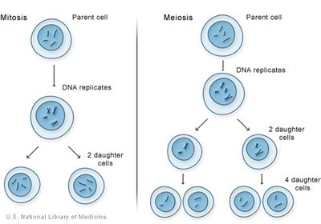

- mitosis produces ______________________________________________________
- meiosis produces _____________________________________________________
The cells created from mitosis are __________________________(46 chromosomes)
The cells created from meiosis are __________________________(23 chromosomes)
- Diploid (2n) – __________ of each type of chromosome (in homologous pair – carry the same trait)
- Haploid (n) –________ of each type of chromosome
Human cells have ________________________________ chromosomes.
Therefore, the diploid number (2n) of chromosomes in humans is ______. (MITOSIS)
The haploid number (n) of chromosomes in humans is ______.(MEOSIS)
Write 3 reasons for mitosis _________________________________________________________
____________________________________________________________________________
Write the main reason for meiosis ____________________________________________________
_______________________ occurs in normal _________________________ cells (i.e. skin cells),
______________________occurs in _________________________ cells (i.e. sperm and egg) only.

