Name________________________ Per:____
How can I explain the causes of motion on an object?
Background: Sir Isaac Newton (1643-1727) an English scientist and mathematician born in Woolsthorpe, England was famous for his discovery of the law of gravity also discovered the three laws of motion. He published them in his book Philosophiae Naturalis Principia Mathematica (mathematic principles of natural philosophy) in 1687. Today these laws are known as Newton’s Laws of Motion and describe the motion of all objects on the scale we experience in our everyday lives.
1st Law: An object ____________________ stays __________________ or an object ____________________, stays in ___________________ (in the same ________/at the same speed) unless acted upon by an _______________ force
Some Examples from Real Life
Two teams are playing tug of war. They are both exerting equal force on the rope in opposite directions. This balanced force results in no change of motion.
Why then, do we observe every day objects in motion slowing down and becoming motionless seemingly without an outside force?
It’s a force we sometimes cannot see __________________
- There are four main types of friction:
  - _______________ friction: ice skating, book sliding across the table
  - _______________ friction: bowling
  - _______________ friction (air or liquid): air or water resistance
  - _______________ friction: initial friction when moving an object
2nd Law
The net force of an object is equal to the product of its mass and acceleration, or F=M x A
A ___________ is a ________________ or a ______________ on an object which causes a _________________ in ___________________.
One example of Newton’s 2nd Law
________________________________________________________________
3rd law: For every ________________, there is an ______________ and _______________ reaction. (Forces are always paired)
One example of Newton’s third law.
________________________________________________________________________________________________________________________________________________________________________________________________

Recognizing motion
- 7.P.1.1 ________________ how the motion of an object can be described by its position, direction and speed compared to something else.
- An object is in ___________when its ___________ from another object is __________.
- Whether an object is moving or not depends on your ____________________________.
Motion and Reference Points
- An object is in _____________________ if it changes _________________ relative to a ___________________ point. A reference point is a place or object used for _________________to determine if something is in motion.
Measuring Motion
- _____________________ is the _____________ an object travels per _____________________.
- If it takes you 1 hour to drive a total of 60 miles, then how fast were you going?
- ________________________.
- To calculate speed:
- Divide the_________________ by the ____________________.
Average Speed
- Most objects do not move at constant speeds for very long. Think about how many stops you have to make on your way to school each day.
- To calculate average speed, is the ___________________________ divided by the _________________________.
Velocity
- Knowing the speed of an object will not tell you everything about its motion.
- Velocity is the _________________ & ___________________ of and object.
- Velocity changes if _________________ speed or direction changes.
- With storms, you need to know the ___________________of its_________________.
Acceleration
- Acceleration is the ____________________ at which velocity __________________.
- It refers to ________________________ (of course), ______________ speed (deceleration), or ______________________ direction.
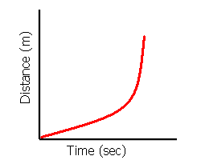
How do you know this graph shows acceleration?
7.P.1.3 I can use a graph to _________________ and ________________ the motion of an object.
- On a motion graph your ________________ variable (the thing you are measuring) is always on the vertical or the ____________ and the thing you are changing the ___________________variable is always on the horizontal or _________________.
- The shape of the graph can tell you a lot about the motion of the object.
Moving or not? Why?
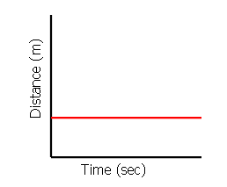
_______________________________________________________________________________________________________________________________________________________________________________________________________________________________________________________________________

Moving or not? How?
________________________________________________________________________________________________________________________________________________________________________________________________________________________________________________________________________________________________________________________________________________________________________________________________________________________________________________________________
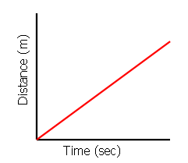
Moving or not? How?
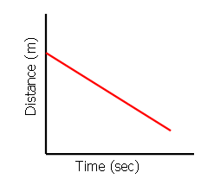
_____________________________________________________________________________________________________________________________________________________________________________________________________________________________________________________________________________________________________________________________________________________________________
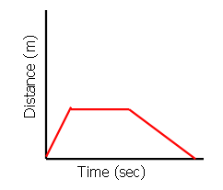
________________________________________________________________________________________________________________________________________________________________________________________________________________________________________________________________________________________________________________________________________________________________________________________________________________________________

Johnny’s mother brought him to school and then came back home for 3 hours. Then she went to the store for 2 hours which was on her way to Johnny’s school. After she was done shopping she continued to Johnny’s school to pick him up and then went back home for the rest of the day.
Draw a graph to show Johnny’s story

