Digestive System and Excretory System

Objective 59: I can describe the parts and functions of the digestive system

- Teeth:
  - _________________________ mechanically by chewing – they grind and crush food into smaller pieces.
- Salivary Glands:
  - Secrete amylase which breaks down starches and sugars in your mouth before you swallow.
- Esophagus:
  - the tube that connects your __________________ and your ____________________________
  - You have a trap door called the ______________________ to cover your windpipe when you swallow.
- Stomach
  - A ______________________________ that holds your food after you eat
  - Helps to break food into smaller pieces so your body can use it for _______________ and nutrition
  - Your stomach ______________________ your food the way a baker kneads dough for bread.
  - Your stomach ____________________ when you eat like a balloon being filled with air
- Small Intestine
  - Tube that is ______ feet long.
  - Continues to digest food
  - Food stays in your small intestine for ______________ hours
- Large Intestine
  - Tube that is ____ feet long
  - Gets waste from ________________________________
  - It is called the LARGE intestine because it is _____________________ than the small intestine.
  - Waste stays for ___________________ hours
- Gall Bladder:
  - Storage tank for ___________________ (a green-yellow liquid) that helps your body break down and use fats
  - Located under your__________________
  - Shaped like a___________________
- Liver
  - Factory for ______________________ and _________________
  - Stores ______________________________________________________ until your body needs them
- Pancreas
  - Helps you digest food by __________________________________________________________
- Rectum
  - A __________________________________________________ before they are excreted from the body
- Interesting Facts
  - Food is in your digestive system for about _________ hours

Objective 60: I can describe how the digestive system works together with other body systems.

- The __________________ system provides every system in the body with the _________________it needs.
- The ___________________ system transports the ____________________ from the ____________________ system to all other systems in the body.

Obj 61: I can describe the parts and function of the excretory system.
- Excretory system: is the system in the body that collects wastes produced by cells and removes them from body.
  - The function of the Excretory system is to eliminate urea, water, and other wastes from the body.
  - Excretion maintains __________________ which means keeping your body’s internal environment (temperature, hydration, energy) stable and free of harmful chemicals.
  - The excretory system is SEPARATE from the digestive system.
  - _______________ = excretory system – waste from cells
  - ____________ = digestive system – waste from food you eat
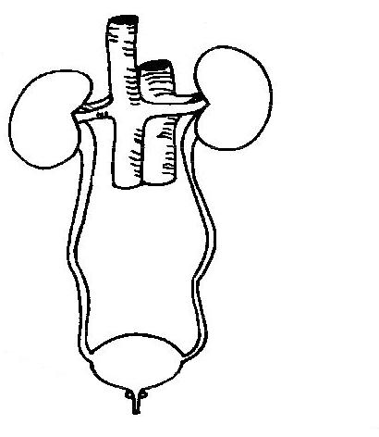
- Parts of the excretory system:

- Kidneys: ________________ urea and other ________________ from the _________________
- Nephron- tiny filtering factories that remove wastes from blood and ______________________.
  - It is made up of ______________ and _________________________.
- Ureters- Urine flows from the kidneys into these two ____________________________________________.
- Urinary bladder- A saclike muscular organ that __________________________.
- Urethra- Urine ___________________________________________ through a small tube.
- Urine- Liquid that is produced in the ______________________ and stored in the _________________________
- Urea- A chemical that contains ________________________________ and is filtered by the kidneys.
- Liver-
  - Breaks down proteins to produce _____________________, ___________________, and _________________________(used in digestion). It stores vitamins and sugar until needed by the body.
  - Used in _________________ and ______________________ system.
- Excretion- The ___________________________________ of wastes from the organs.
- Respiration- The process in which oxygen and glucose undergo a complex series of chemical reaction inside cells. The waste product of respiration is carbon dioxide.
- Skin-
  - It is our body’s ____________________________
  - part of the ____________________ system and the ________________________ system.
  - The skin excretes ____________________________ to help our bodies maintain homeostasis
- Perspiration- Excreted by the skin containing water, salt, and urea.

Obj 62: I can describe how the excretory system works with other organ systems in the body
- The ________________ system works with the ________________ system by removing waste from the blood.
- The _________________ system works with the integumentary system (your skin, hair, nails) to maintain homeostasis

