Digital Media Presentation
(Climate Change, Pollution, or Environmental Stewardship)
 | 5 | 4 | 3 | 2 | 1
Chosen Media  The organization and integration of media objects such as text and graphics to represent and convey information.  Electronic media also may include video, animation, and sound, etc… | Students have used media in exemplary, creative and effective ways; All elements make a contribution to the final product; There are few minor technical problems | Students have used media in an attractive, easy-to-follow format. With minor exceptions, all elements contribute rather than detract from the presentation's overall effectiveness. | Students have used media adequately; Some technical problems, but the viewer is able to follow the presentation with few difficulties. | Students used limited amounts of organization and is confusing; Technical difficulties seriously interfere with the viewer's ability to see, hear, or understand content. | The presentation is of poor quality and is disorganized and difficult to follow.
Collaboration  Working together jointly to accomplish a common intellectual purpose in a manner superior to what might have been accomplished working alone. | Students were a very effective team. Division of responsibilities capitalized on the strengths of each team member. The final product was shaped by all members and represents something that would not have been possible to accomplish working alone. | Students worked together as a team on all aspects of the project. There was an effort to assign roles based on the skills/talents of individual members. All members strove to fulfill their responsibilities. | Students worked together on the project as a team with defined roles to play. Most members fulfilled their responsibilities. Disagreements were resolved or managed productively. | Presentation is the result of a group effort, but only some members of the group contributed. There is evidence of poor communication, unresolved conflict, or failure to collaborate on important aspects of the work. | Presentation was created by one student working more or less alone (though may have received guidance or help from others).
Content  The topics, ideas, concepts, knowledge, and opinions that constitute the substance of the presentation. | The content presented is superior and clearly demonstrates a solid understanding of the topic. It reflects broad research and application of critical thinking skills; shows notable insight or understanding of the topic; compels the audience's attention. | The project has a clear goal related to a significant topic or issue. Information included has been compiled from several relevant sources. The project is useful to an audience beyond the students who created it. | The project presents information in an accurate and organized manner that can be understood by the intended audience. There is a focus that is maintained throughout the piece. | The project has a focus but may stray from it at times. There is an organizational structure, though it may not be carried through consistently. There may be factual errors or inconsistencies, but they are relatively minor. | Project seems haphazard, hurried or unfinished. There are significant factual errors, misconceptions, or misunderstandings
Communication  Expression of ideas  and information, use of  scientific vocabulary | Organization of ideas and  information is clear, logical and informative; excellent use of  vocabulary | Organization of ideas and  information is (at least 2  of) clear, logical and  informative; excellent use of vocabulary, some errors | Organization of ideas and  information is (at least 1  of) clear, logical and  informative; good use of vocabulary; some errors | Organization of ideas and  information is not clear,  logical or informative; good use of vocabulary; several errors
Solution to Issue  - What are the social, economic and environmental impacts?  - What are we doing about it?  - What should we be doing about it? | Makes connections  between science,  society and  the environment with a  high degree of  effectiveness; All three questions answered completely and  with significant information | Makes connections  between science,  society and  the environment with  considerable effectiveness; All three questions answered completely with  some information | Makes connections  between science,  society and  the environment with  some effectiveness; All three questions answered completely with  little information | Makes connections  between science,  society and  the environment with  limited effectiveness; At least two of the three  questions answered  completely with  information

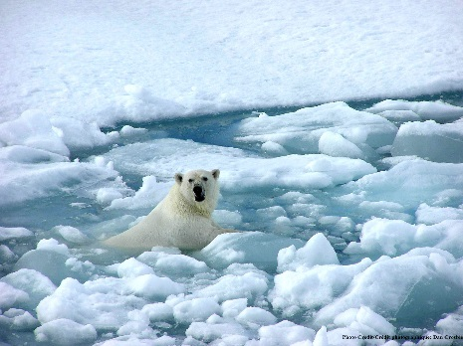
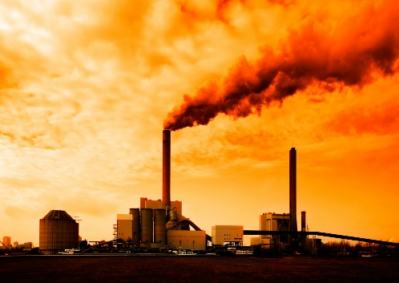

Digital Media Presentation
(Climate Change, Pollution, or Environmental Stewardship)
Over the past quarter, we have discussed many different issues that directly affects us, the community we live in, as well as others around the world. Climate Change, Pollution, and the idea of Environmental Stewardship are issues that are heavily debated today, and will be necessary to address for generations to come. Your team will create a digital media presentation that focuses on ONE of the above topics. Within your presentation your team needs to address the following…
- Define the issue/idea
- Explain the social, economic and environmental impacts
- Explain what the local, national and global communities are doing about the issue
- Offer suggestions (with support) on what you, the local, national and global community should be doing to address these issues/ideas.
Your team will create a final product using digital media. You may choose to create your product with the following web based apps…
- Educreations
- Thinglink
- Voice Thread
- Stop Motion
- Picktochart (computer/laptop needed)
- Other web based program and/or digital media idea approved by your teacher

