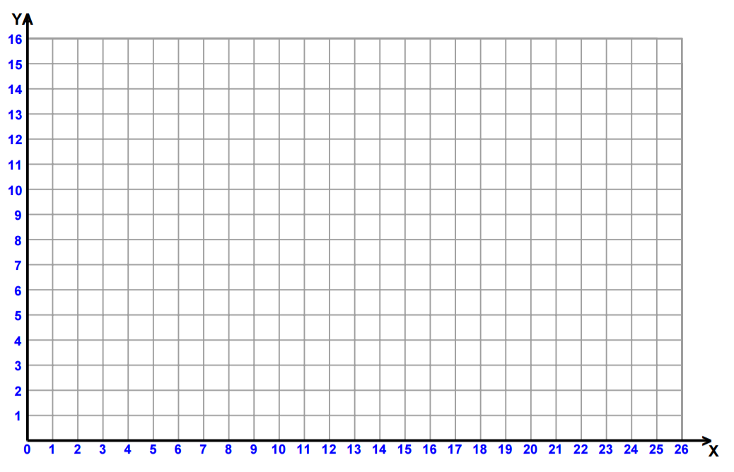
DISTANCE – TIME Graphs
MOTION: The ______________ in ______________ measured by distance & time

SPEED =
VELOCITY: The ____________ and ____________ of a moving object

DISTANCE =
SPEED: the _________ at which an object is ______________
TIME =
ACCELERATION: the _________ at which speed or direction _______________

A DISTANCE TIME GRAPH SHOWS: ______________________________________ ______________________________________________________________________
Ex.
A CURVED line means…

A STRAIGHT line means…

A HORIZONTAL line means…

Ex.
Ex.

?? An object travels 2 meters in 1 second. It then travels another 3 meters in 3 seconds. What was the objects average speed??

