Electricity & Circuits

Objective 1: I can explain the sources of Electrical Energy

- Electrical energy: the movement of _________________________

- Electrical Energy comes from many sources such as:

  - __________________________ – (Hydroelectric) & _______________________
    - Both water and wind power are used to turn a ____________ that creates _____________ (green) electrical energy
  - _____________ – (sun energy) heat energy is turned into electrical – green energy
  - ___________________– (energy from atoms) –green energy
  - ___________________ - (Batteries)

Objective 2: I can describe series and parallel circuits

- Circuit: _______________ through which ______________ can ______________

- A simple circuit only need 3 things _________________, ____________________, ___________
- Circuit Components
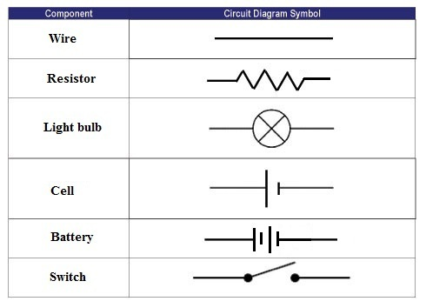

Types of Current
- D/C____________________
  - Can ___________ travel ___________ distances
  - __________________ travel in ____________________________
  - Electricity we get from ________________________

- A/C____________________
  - Can _________________ over ______________ distances
  - ________________________ directions forward and backward (__________________)
  - Electricity we get from _______________________ - anything you have to ________________

Types of Circuits

Series Circuit: current travels in a ____________________________ from ____________________________
  - one break ________________the _______ of current (if one light goes out they ALL go out)
  - current is the _____________throughout circuit
SERIES CIRCUIT DRAWING
    - lights are _______________________________
  - each device _______________________ of the total voltage
    - get ___________________ as lights are added

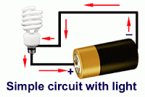

Parallel Circuits
  - current travels in ___________________________ from negative to positive
    - one break ______________________ flow
  - current ___________ in ______________ branches
PARALLEL CIRCUIT DRAWING
  - takes path of_______________ resistance
  - “______________” light would be __________
  - each device receives the _________________
  - _____________________when lights are added
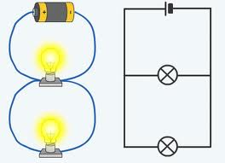

Household Circuits
- Combination of _____________________________
  - too many devices can cause wires to ______________
- Safety Features:
  - ________________ - metal melts, breaking circuit
  - _____________________ - bimetallic strip bends when hot, breaking circuit

