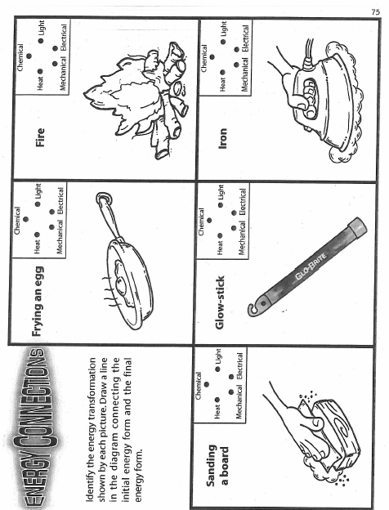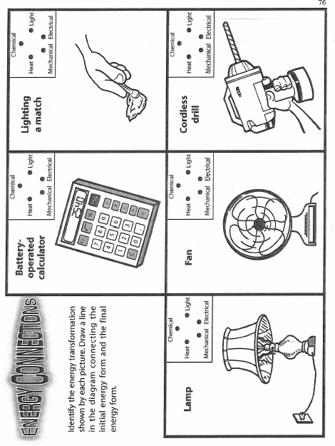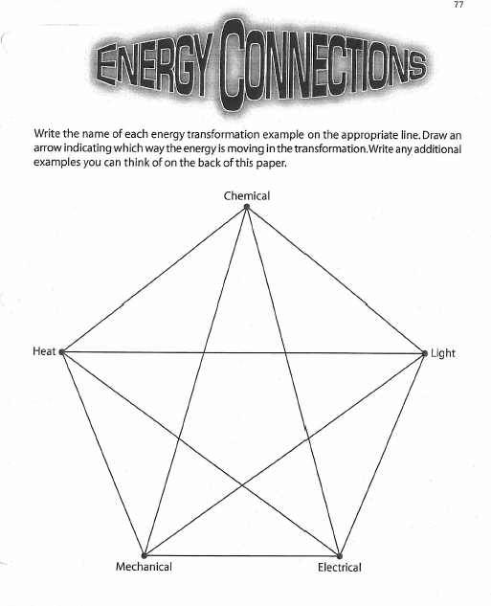

Energy Connections Conclusion Question
Name: _____________________________ Period ____
Learning Goal: Identify the energy transformations shown in a series of pictures.
- What is the Law of Conservation of Energy? ________________________________________
____________________________________________________________________________
____________________________________________________________________________
- Is it possible that there is more than one correct answer for some pictures? Why or why not?

- List 2 other energy transformations you were able to think of that were not on this activity.
  - Example: Transformation:

  - Example: Transformation:

- What is an energy transformation happening in the classroom right now?
  - Example: Transformation:

- What is an example of an energy transformation involving nuclear energy?
  - Example: Transformation:

- What is an example of an energy transformation involving sound energy?
  - Example: Transformation:

- Describe two energy transformations that occur in a LIVING THING.
  - Example: Transformation:

  - Example: Transformation:

