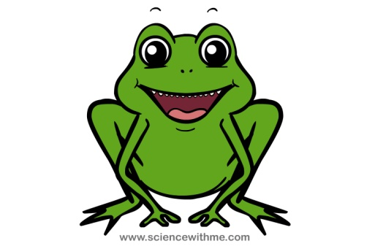Name: ___________________________________________ **Day 1**

**Frog External Anatomy**

1. Observe the dorsal (back) and ventral (belly) sides of the frog.
   1. Dorsal side color ______________________
   2. Ventral side color ______________________
   3. Why do you think the frog has different colors on the dorsal and ventral sides? _______________________________________________________________________________________________________________________________________________________________________________________________________________________________________________________________
2. Examine the hind legs and forelegs. How many toes are present? Are they webbed?
   1. Hind leg toes _________________ Webbed? _______________
   2. Foreleg toes __________________ Webbed? _______________
   3. Why are webbed toes important? _________________________________________________________

_____________________________________________________________________________________

1. Use a ruler to measure your frog, measure from the tip of the head to the end of the frog’s backbone (DO NOT INCLUDE THE LEGS IN YOUR MEASUREMENT)
2. Locate the frog’s eyes, the nictitating membrane is a clear membrane attached to the bottom of the eye. Use tweezers to carefully remove the nictitating membrane. You may also remove the eyeball.
   1. What color is the nictitating membrane? ____________________
   2. Why do you think a frog has a nictitating membrane? _________________________________________

_____________________________________________________________________________________

* 1. What color is the eyeball? ______________________________________

1. Just behind the eyes of the frog’s head is a circular structure called the tympanic membrane, which is used for hearing. Measure the diameter of the tympanic membrane. __________________________cm
2. Fell the frog’s skin. Is it scaley or slimey? ______________________

**Anatomy of the Frog’s Mouth**

Procedure: Pry the frog’s mouth open and use scissors to cut on each side of the jaw so you can open the frog’s mouth wide enough to view the structures inside.

1. Locate the tongue. Play with the tongue. Does the tongue attach to the front or back of the mouth? ______________ - remove the tongue
2. In the center of the mouth **(#1),** toward the back is a single round opening. This is the ________________________ that leads to the stomach. Use the probe to poke into the esophagus.

3

2

1. Locate the Eustachian tubes **(#2)** inside the mouth. Eustachian tubes equalize pressure for the

frog in the inner ear when it is swimming. Insert a probe into the Eustachian tube.

To what structure does the Eustachian tube attach? ___________________

1

1. Just behind the tongue, and before the esophagus is a slit like opening. This is called the

Glottis **(#3)** and it is the opening to the lungs. The frog vocalizes with the glottis.

1. The frog has two sets of teeth. The vomarine teeth(#1) are found on the

3

2

roof of the mouth. The maxillary teeth (#2) are found around the edge of

the mouth. You have to feel them with your finger. Both are used for holding

prey, frogs swallow their meals whole, they DO NOT chew.

1. On the roof of the mouth, you will find two tiny openings, if you put your probe

1

into these openings, you will find they exit on the outside of the frog. These

are the nostrils.

1. Complete the following chart:

|  |  |  |
| --- | --- | --- |
| Structure | Function | Location |
| Vomarine Teeth |  |  |
| Eustachian Tubes |  |  |
| Nictitating Membrane |  |  |
| Tympanic Membrane |  |  |
| Esophagus |  |  |
| Glottis |  |  |
| Tongue |  |  |

**Label the following structures:**



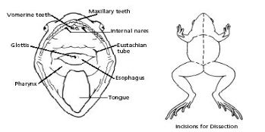**Internal Structures:**

1. Place the frog on the tray ventral (belly) side up.
2. Use scissors to lift the abdominal muscles away from the body cavity.

Cut along the midline of the body from the pelvic to the chin area of the frog.

1. Make transverse (horizontal) cuts near the arms and legs.
2. Remove the flaps from the body

Name: __________________________________________ Day 2



Identify the following structures

1. ______________________________________
2. ______________________________________
3. ______________________________________
4. ______________________________________
5. ______________________________________
6. ______________________________________
7. ______________________________________
8. ______________________________________
9. ______________________________________
10. ______________________________________
11. ______________________________________
12. ______________________________________
13. ______________________________________
14. ______________________________________

Male Frog Urogenital System Female Frog Urogenital System



**Exploring the Stomach**

1. Removal of the Stomach: Cut the stomach out of the frog and open it up (Cut it hotdog style) You may find what remains of the frog's last meal in there. Look at the texture of the stomach on the inside.

What did you find in the stomach? ___________________________________________________________________

1. Now using your pointer, put it through the esophagus in the mouth, you should be able to see how the esophagus connects directly to where the stomach was.
2. Measuring the Small intestine: Remove the small intestine from the body cavity and carefully

separate **the mesentery** (connective tissue)from it. Stretch the small intestine out and measure it.

Small Intestine length ______________________cm

**Some Post Lab Questions**

1. What is the name of the membrane that holds the coils of the small intestine together?
2. What is the organ that is found under the liver that stores bile.
3. Name the 3 lobes of the liver:
4. What is the organ that is the first major site of chemical digestion?
5. What is the structure that eggs, sperm, urine and wastes all empty into?
6. The small intestine leads to the:
7. The esophagus leads to the:
8. Yellowish structures that serve as an energy reserve:
9. The first part of the small intestine(straight part):
10. After food passes through the stomach it enters the:
11. The spiderweb like membrane that covers the organs is called:
12. This regulates the exit of partially digested food from the stomach:
13. The large intestine leads to the :
14. Organ found within the mesentery that stores blood:
15. The largest organ in the body cavity: