Name:___________________________________ Pd:_____ Date:_____________________
Frog Legs Lab (____ /30points)
 | Height Jumped | Distance Jumped
Paper trial 1

Paper trial 2

Average

(data tables = 3 pts each)
Procedure:
- Find the frog made out of paper and make it jump by gently pushing on the back of the paper. Record how far the frog jumps in cm. Do two trials and find the average distance.

- Find the frog made out of paper and make it jump by gently pushing on the back of the paper. Record how high the frog jumps in cm. Do two trials and find the average height
- Repeat steps 1 and 2 for the frog made out of card stock

- Repeat steps 1 and 2 with the card stock frog with the plastic strip placed inside the CARD STOCK frog.

 | Height Jumped | Distance Jumped
Card Stock
trial 1
Card Stock
trial 2
Average

 | Height Jumped | Distance Jumped
Card stock and plastic - 1
Card stock and plastic - 2
Average

Analysis Questions: Answer each question in complete sentences.

- What are the kinds of potential energy that your frogs had in this lab? (3pts)

- What are some other examples of things that have elastic potential energy?
Gravitational potential energy? (2pts)

- What is kinetic energy? What are some examples of things that have kinetic energy? (2pts)

- How high and how far did the paper jump? (2pts)

- How did this compare to the distances jumped by the other types of frogs? (1pt)

- What might be some reasons for any differences? (1pt)
- How high and far did the card stock frog jump? (1)

- How did this compare to the distances jumped by the other frogs? What might be some reasons for any differences? (1)

- At what point did the frog have the most potential energy? Why? (1pt)

- When did the frog have the most elastic potential energy? Why? (2pts)

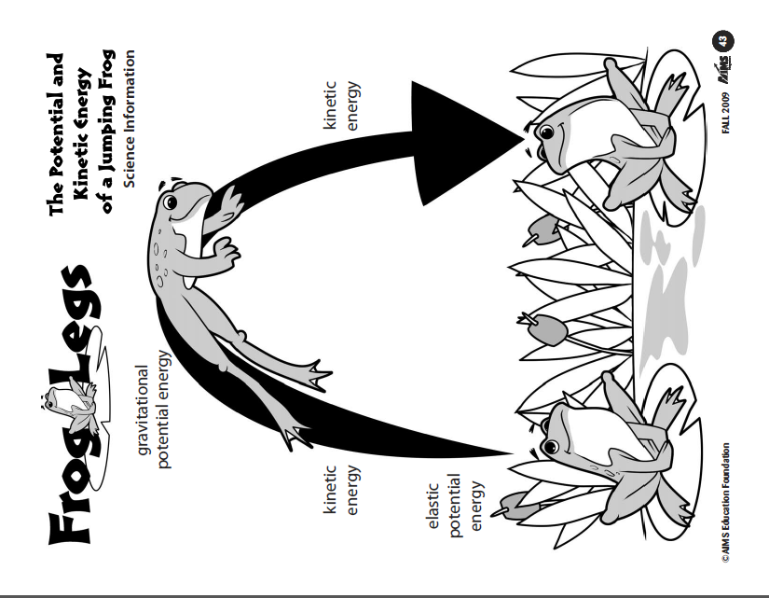
- Label the diagram below identify the points where the frog has kinetic, potential, gravitational, and elastic potential energy.(5pts)

