Name_______________________________________________________ Date____________________
Genetics Study Guide
- Give an example of a trait that is influenced by the environment.
- What is an example of something from the environment that affects your existing genetic factors?

- Name a trait that is purely a genetic trait.
- What is an environmental trait?
- Why does sexual reproduction produce greater variations?
- Single celled organisms reproducing and creating cells exactly like themselves without combining genes from two different parents is an example of ________________________.

- In asexual reproduction in plants, how does the genetic material compare between the new plant and the parent plant?

- Define sexual reproduction.
- Name the parts of the cell theory.
- What is the basic structure and function of all life?
- Red green colorblindness is a recessive sex-linked trait located on the X chromosome. Who is more likely to get it and why?

- Sex linked genes are on what chromosomes?
- A father does not have hemophilia, but the mother is a carrier. If hemophilia is a sex linked trait on the X chromosome, what is the probability of having a child with hemophilia?

- What causes Down Syndrome?
- What is sickle cell anemia?
- What is cystic fibrosis?

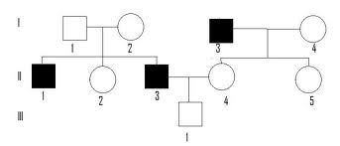
- Below is a pedigree showing a recessive trait. What is the possible genotype for Individual 1, generation I?

- What is the possible genotype for Individual 2, generation II?
- What is the possible genotype for individual 1, generation II?
- What is mitosis?
- Meiosis results in ____________ the number of chromosomes of the parent cell.
- Mitosis results in ____________the number of chromosomes of the parent cell.
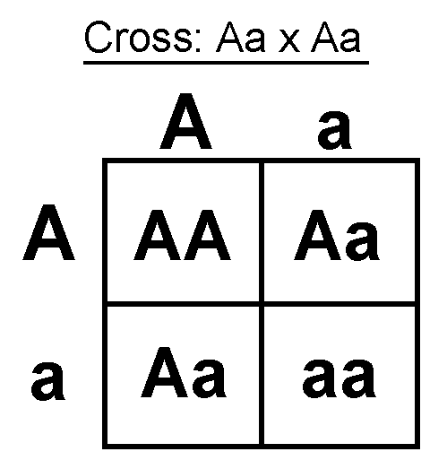
- What is the probability that the offspring will be homozygous dominant?

- Using the same punnett square as above, what is the probability that the offspring will be heterozygous?

- Patrick recently married Patti, a cute girl he met at a local dance. He is considered a purebred for his tall head shape (T), which is dominant over a short head (t). If Patti is a short-headed woman, what type of heads would their children have?

- In rabbits white fur is dominant to brown fur. If the mother is homozygous recessive and the father is heterozygous, what is the probability of the offspring having brown fur?

- Make sure you know these skills:
  - Make a pedigree chart based on a scenario
  - Difference/similarities of mitosis and meiosis
  - Difference and influences in environmental traits and genetics
  - Examples of genetic disorders including symptoms and how they are obtained

