Name_______________________________________________________ Date____________________
Genetics Study Guide
- Give an example of a trait that is influenced by the environment.
  - Obesity/Skin Cancer/Height and Skin color can be influenced by the environment
- What is an example of something from the environment that affects your existing genetic factors?
  - Diet/Sun exposure

- Name a trait that is purely a genetic trait.
  - Widows Peak/Attached Earlobes/Blood Type
- What is an environmental trait?
  - A trait developed from an organisms surroundings
- Why does sexual reproduction produce greater variations?
  - DNA comes from 2 genetically different parents
- Single celled organisms reproducing and creating cells exactly like themselves without combining genes from two different parents is an example of ________________________.
  - Asexual reproduction

- In asexual reproduction in plants, how does the genetic material compare between the new plant and the parent plant?
  - They are identical

- Define sexual reproduction.
  - Reproduction by 2 parents that produce genetically different offspring
- Name the parts of the cell theory.
  - Cells come from other cells
  - All living things are made of cells
  - The cell is the basic unit of life in all living things
- What is the basic structure and function of all life?
  - Cells
- Red green colorblindness is a recessive sex-linked trait located on the X chromosome. Who is more likely to get it and why?
  - Both males and females can get sex-linked traits, but males are more likely because they only have 1 X chromosome and it doesn’t match with the Y chromosome

- Sex linked genes are on what chromosomes?
  - 23rd set of chromosomes - the X and Y chromosomes
- A father does not have hemophilia, but the mother is a carrier. If hemophilia is a sex linked trait on the X chromosome, what is the probability of having a child with hemophilia?
  - 25%
  - Mom XXh
  - Dad XY

- What causes Down Syndrome?
  - 3 copies of the 21st chromosome….chromosome fails to separate during meiosis
- What is sickle cell anemia?
  - Abnormally shaped blood cells that can’t carry as much Oxygen
- What is cystic fibrosis?
  - Unusually thick mucus in the lungs and intestines
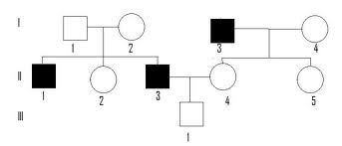
- Below is a pedigree showing a recessive trait. What is the possible genotype for Individual 1, generation I?

Aa….has to be a carrier because his child is affected by the trait
- What is the possible genotype for Individual 2, generation II? AA or Aa

- What is the possible genotype for individual 1, generation II? aa
- What is mitosis?
  - Occurs in all the BODY cells and produces 2 identical daughter cells
- Meiosis results in __half___ the number of chromosomes of the parent cell.
- Mitosis results in _the same___the number of chromosomes of the parent cell.
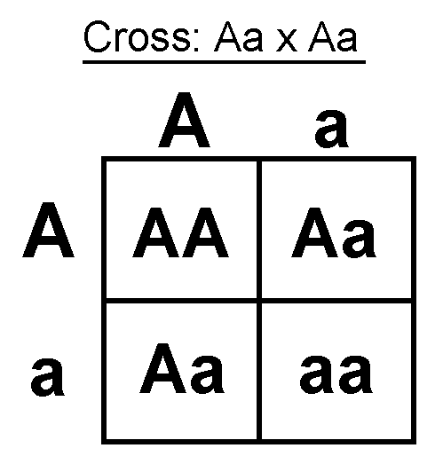
- What is the probability that the offspring will be homozygous dominant?

- AA= 25%
- Using the same punnett square as above, what is the probability that the offspring will be heterozygous?
Aa = 50%

- Patrick recently married Patti, a cute girl he met at a local dance. He is considered a purebred for his tall head shape (T), which is dominant over a short head (t). If Patti is a short-headed woman, what type of heads would their children have?
  - TT/tt
  - All children will have tall heads (heterozygous) Tt

- In rabbits white fur is dominant to brown fur. If the mother is homozygous recessive and the father is heterozygous, what is the probability of the offspring having brown fur?
Ww/ww
50% will have brown fur

- Make sure you know these skills:
  - Make a pedigree chart based on a scenario
  - Fill in Punnett squares and answer questions
  - Difference/similarities of mitosis and meiosis
  - Difference and influences in environmental traits and genetics
  - Examples of genetic disorders including symptoms and how they are obtained

