Guided Notes: Graphing and Microscopes Obj 7-9

Objective 7: I can identify ______________________________________________
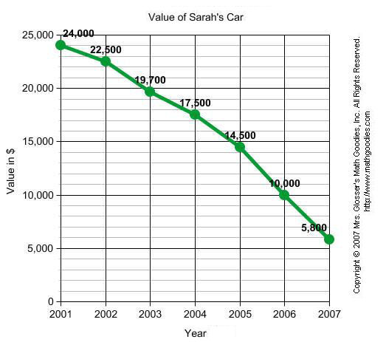
Label the parts of a graph:
3.
4.
5.
2.
1.

Objective 8: I can ________________________________________________________________ to create based on my data

- Bar Graphs: are used when we are ______________________________ 2 or more things

- Line Graphs: are used when showing a ____________________________________________________________

- Circle Graph or Pie chart: is used to show ___________________________________________________ all of the parts need to add up to __________%

Line Graphs:
  - If you have more than one line you need to have a_________________

  - Points from different lines can SHARE THE SAME _________________ on a graph.

Objective 9: I can describe what is happening based on the_____________________of the graph:
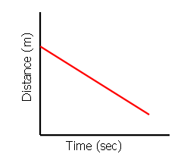
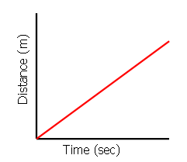
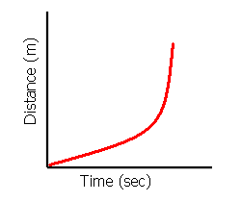
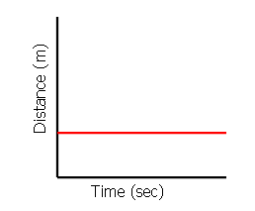
Label what is happening on each graph
Constant velocity increasing distance
Object is not moving
Graphing Story:

Graphing Stories:

Johnny’s mother brought him to school and then came back home for 3 hours. Then she went to the store for 2 hours which was on her way to Johnny’s school. After she was done shopping she continued to Johnny’s school to pick him up and then went back home for the rest of the day.

Distance

5
6
2
1
7
4
3
8
Time

Label what is happening on each part of the graph
- Johnnys mother brings him to school.
- __________________________________________
- His mother is home for 3 hours
- _________________________________________
- She is at the store for 2 hours
- _________________________________________
- She comes home from school
- She stays home for the rest of the day

