Guided Video Notes –Objectives 51 – 52
Objective 51: I can describe how alleles can be _______________
Human Blood Type
There are three alleles that code for blood types
A (written as I^{A}) - ______________________
B (written as I^{B}) - ______________________
O (written as i) –_______________________
Fill in the table below:
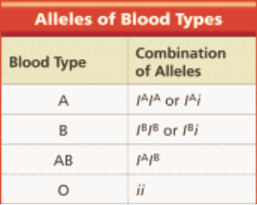
Human Blood Type
- A person who inherits an I^{A} allele from one parent and an I^{B} allele from the other parent will have type _______ blood
Questions
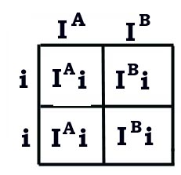
- A woman with Type O blood and a man who is Type AB are expecting a child. What are the possible blood types of the kid?

______________% will be heterozygous for type A

______________% will be heterozygous for type B

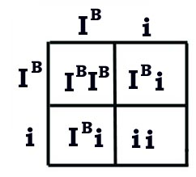
- What are the possible blood types of a child who's parents are both heterozygous for "B" blood type?

______________% will be heterozygous for type B

______________% will be homozygous for type O

Traits controlled by several genes
- You don’t just have a tall gene or a short gene….
- In fact ____________________ is controlled by 4 different genes.
- ___________________ is also controlled by multiple genes

Objective 52: I can make a pedigree chart to determine how traits were passed down through generations

- Pedigree charts show a __________________________________________________ of an individual
- They can be used to study the transmission of a __________________condition
- They are particularly useful when there are large families and a good family record over several generations.

Symbols used in pedigree charts - Draw in the symbols

Organizing the pedigree chart
A ______________________________chart of a family showing 20 individuals

Generations are identified by ____________________________

Draw a pedigree of your immediate family showing your parents and your siblings

