We’ve got Guts! 7th Grade Science Project.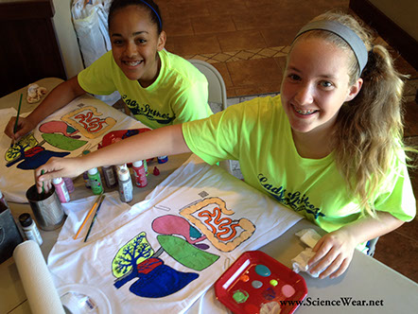
Dear Parents,
During the 4th quarter we will be studying Human Body Systems. One of the projects we will be doing this year is painting and labeling a “guts” t-shirt which displays the circulatory, respiratory, and digestive systems on a t-shirt. The cost of this project is $6.00 and money needs to be turned in by April 21st so we have time to order the t-shirts. Please fill out the form below and return to your child’s science teacher. If you would like to sponsor a t-shirt for another child you can send in that money as well. T-shirts are adult sizes S-XL. Checks must be made out to Daniels Middle School.
Return this portion with $6.00 by April 21st
Name: __________________________
T-shirt size: S MED LG XL XXL

