Name:______________________ Per:____
Human Reproduction Activity Responses
Key Vocabulary: Amniotic sac Estrogen Fetus Semen Testes Vagina Egg Fallopian tubes Ovaries Sexual reproduction Testosterone Vas Deferens embryo fertilization penis Sperm Uterus Zygote
STOPPING TO THINK 1
What is a zygote and how does it form?
_______________________________________________________________________________________________________________________________________________________________________________________________________________
STOPPING TO THINK 2
a. Using the diagram on pg. 11, describe the path of sperm from the testis to the outside of the male body.
_______________________________________________________________________________________________________________________________________________________________________________________________________________
b. What is the relationship between sperm and semen? _______________________________________________________________________________________________________________________________________________________________________________________________________________
c. How do you think a high fever might affect sperm production? Explain.
_______________________________________________________________________________________________________________________________________________________________________________________________________________
STOPPING TO THINK 3
a. Use the diagram on pg. 12 to describe the path of an egg from the ovary to the outside of the female body.
_______________________________________________________________________________________________________________________________________________________________________________________________________________
b. Look at the photograph of a sperm at the beginning of this reading. How does a sperm’s structure help it get to the egg in the fallopian tube? __________________________________________________________________________________________________________________________________________
STOPPING TO THINK 4
a. What is the difference between a zygote and an embryo? _____________________________________________________________________
_____________________________________________________________________
b. Why is it important for a mother to take good care of herself when she is pregnant? _____________________________________________________________________
_____________________________________________________________________
ANALYSIS
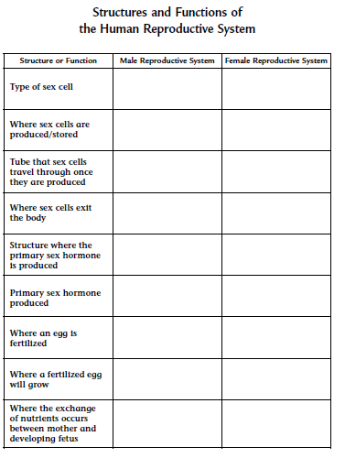
- Complete “Structures and Functions of the Human Reproductive System,” by listing the organ or structure that matches each function or structure in the table above.
2. Describe the stages an egg goes through from fertilization to the birth of a baby.
_____________________________________________________________________
_____________________________________________________________________
_____________________________________________________________________
_____________________________________________________________________
_____________________________________________________________________
_____________________________________________________________________
_____________________________________________________________________
_____________________________________________________________________

3. Describe the function of each of the following structures in the development of a fetus:
a. Amniotic Sac _____________________________________________________________________
_____________________________________________________________________
b. Placenta _____________________________________________________________________
_____________________________________________________________________
_____________________________________________________________________
c. Umbilical Cord _____________________________________________________________________
_____________________________________________________________________

4. Imagine you are a doctor and one of your patients just found out she is pregnant. Knowing that anything she takes into her body can cross the placenta and affect the developing fetus, what will you recommend to her in order to have a healthy baby? _____________________________________________________________________
_____________________________________________________________________
_____________________________________________________________________
_____________________________________________________________________
_____________________________________________________________________
_____________________________________________________________________
_____________________________________________________________________

Label the parts of each of the systems below
The Male Reproductive System

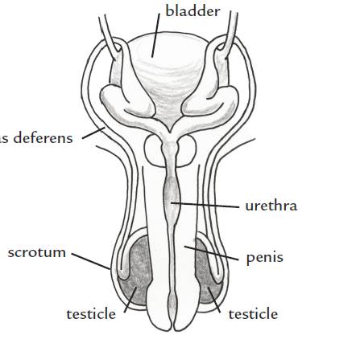
The Female reproductive system
