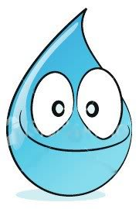
Journey as a Water Droplet

Let’s take a journey through the water cycle as a water droplet! Where do you think you will go? How will you get there? What will happen along the way? Let’s find out!
Station | What happened? | Where are you going?

