Keys to success on the 4th Quarter Exam
Name: ___________________ Per: ____
7. L.2.2 Infer patterns of heredity using information from Punnet Squares and Pedigree analysis.
1. How many pairs of chromosomes do humans have? ______
2. What are sex linked traits and on what chromosomes are they found?

3. What are autosomal traits and on what chromosomes are they found?

4. What combination of chromosomes lead to a male_____, what combination leads to a female___?
5. How does sex linked traits affect humans? (Who can be affected?)

6. Colorblindness is a sex linked recessive trait. A color blind man has children with a woman who is a carrier, what is the probability of having a child who is colorblind. Remember you must use X^{c} and Y when dealing with sex linked traits. Draw a Punnett Square and explain the results.

7. Define the term carrier? How can we determine if someone is a carrier?

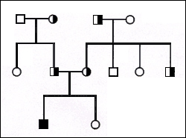
8. Examine the pedigree below. A half shaded circle or square means the person is a carrier but doesn’t show the disorder. Label each individual in the pedigree with a letter above their circle or square. Write the genotype of each individual below their circle or square.
a. How many persons have the trait we are looking at? _____
I
b. How many individuals are carriers? _____
c. How many individuals are not affected by the trait? _____
c. This trait has been in the family for 3 generations why did it only show up in the 3rd generation?
II
III
d. What is the mode of inheritance of this trait?

7.L.2.3 Explain the impact of the environment and lifestyle choices on biological inheritance (to include common genetic diseases) and survival.
1. Define genetic traits and list some examples.

2. What is an environmental trait and list a few examples?

3. What is a genetic disorder and how do people get them?

4. Describe the following genetic disorders.
a. Down Syndrome:

b. Sickle cell:

c. Hemophilia:

d. Cystic Fibrosis:

4. How does the environment and lifestyle choices affect the quality of a person’s life?

5. List a few lifestyle choices that can enhance (make better) your quality of life?

6. List a few genetic traits that can be influenced by the environment.

7.L.1.4 - Summarize the general functions of the major systems of the human body (digestion, respiration, reproduction, circulation, and excretion) and ways that these systems interact with each other to sustain life.
1. What is the role of the digestive system?

2. What is chemical digestion and where does it begin?
3. What is mechanical digestion and where does it begin?

4. List the path food takes through the Alimentary Canal (Digestive System)

5. Describe what each part of the digestive system does to/for food as it travels through it.
Mouth/Teeth:
Esophagus:
Stomach:
Small Intestines:
Large Intestines:
Rectum:
Anus:
The Liver, Pancreas and Gall Bladder are described as accessory organs of the digestive system, why is this so and what do they do?
Liver:
Pancreas:
Gall Bladder:
6. What is the function of the circulatory system?

7. What is the major function of the circulatory system?

What do the following organs/blood vessels do?
Heart:
Veins:
Arteries:
Red Blood Cells:
White Blood Cells:
Platelets:
Plasma:
8. Describe the flow of blood from the heart through the blood vessels and back to the heart.

9. How does the circulatory system work with the digestive system?

10. What is the function of the Excretory System?

11. List the pathway urine takes to exit the body.

12. What are the functions of the following organs?
Urethra:

Kidney:

Ureter:
Bladder:
13: How does the Excretory System work with the Circulatory System?

14: What is the function of the Respiratory System?

15. Draw and label the respiratory system, include the following organs, Mouth, Trachea, Bronchi, Bronchioles, Alveoli.

16. The Respiratory system has cilia that line certain organs. What organs are lined with cilia and what is the purpose?

17. How does the Respiratory System work with the Circulatory System?

7.L.2.2 Infer patterns of heredity using information from Punnett squares and pedigree analysis….cont’d
1. Look at the following pedigree and identify the mode of heredity as sex linked, autosomal recessive, or autosomal dominant and explain your reasoning.
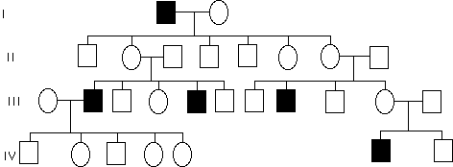
Mode of Inheritance:

Reason:

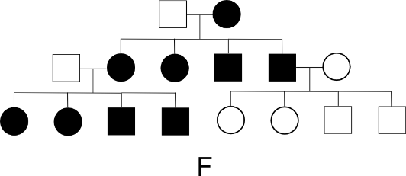
Mode of Inheritance:
Reason:

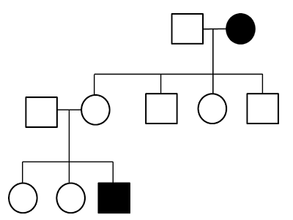
Mode of Inheritance:
Reason:

2. The following pedigree shows an X link recessive trait fill out the genotypes of all individuals to complete the pedigree. Remember Sex Linked pedigrees use the X and Y notation. Use X^{R}X^{R}, X^{R}X^{r}, X^{r}X^{r} for females and X^{R}Y, X^{r}Y for males.
