Name:_______________________ Pd:____ Date:_____________________
Keys to Success on the Quarter 3 EXAM

7.L.1.1 Compare the structures and life functions of single-celled organisms that carry out all of the basic functions of life .

- Fill out the following table for the unicellular organisms we studied

Draw the Protist | What Organelles are Present? | How does it move? | How does it get food? | Special features
Amoeba

Volvox

Paramecium

Euglena

7.L.1.2 Compare the structures and functions of plant and animal cells, including major organelles .

- Label the following Cells and their organelles and in the table below select whether the organelle is found in plants, animals or both, describe what the organelles do.
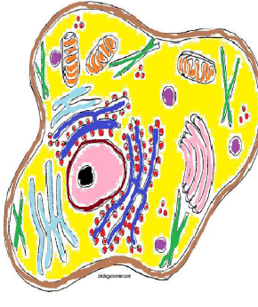

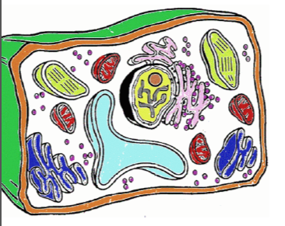

Organelle | Found in Plants | Found in animals | Function
Cell Wall

Cell Membrane

Mitochondria

Cytoplasm

Chloroplast

Nucleus

Golgi Body

Vacuole

Endoplasmic Reticulum

Ribsomes

Nucleolus

7.L.2.1 Explain why offspring that result from sexual reproduction (fertilization and meiosis) have greater variation than offspring that result from asexual reproduction (budding and mitosis).

- What is sexual reproduction?

- What is asexual reproduction?

- What is the purpose of mitosis and where does it happen? What kind of cells are produced?

- If a single cell starts out with a diploid number of 98 chromosomes and undergo mitosis how many new cells will be formed and how many chromosomes will each new cell have? Draw a picture to show the process.

- What is the purpose of meiosis and where does it happen? What kind of cells are produced?

- If a single cell starts out with a diploid number of 98 chromosomes and undergo meiosis how many new cells will we have in the end and how many chromosomes will each new cell have? Draw a picture to show the process.

- What is the difference between offspring that result from sexual reproduction vs asexual reproduction include, complexity of the offspring, number of parents, relative parental care, and genetic variation in the offspring.

7.L.2.2 Infer patterns of heredity using information from Punnett squares and pedigree analysis.
- Mendel worked with pea plants and made the following crosses. Complete the Punnett Squares and below each square put the genotypes and phenotypes formed and list their percentages.
R = red, r = white
a. Homozygous Dominant X Homozygous Recessive b. Homozygous Dominant X Heterozygous

c. Heterozygous X Heterozygous d. Heterozygous X Homozygous Recessive

- Let’s say that in seals, the gene for length of the whiskers has two alleles. The dominant allele (W) codes long whiskers and the recessive allele (w) codes for short whiskers.
  - What is the probability of producing offspring that have short whiskers from a cross of two long-whiskered seals, one that is homozygous dominant and one that is heterozygous? Show your work on the Punnett Square.

_____ % long whiskers

_____% short whiskers

- In purple people eaters, one horn (H) is dominant and no horns (h) is recessive. Complete the Punnett Square to show the cross of two hybrd purple people eaters. Summarize the genotypes and phenotypes of the possible offspring.

Possible genotypes of offspring:

Possible phenotypes of offspring:

- In Noombats, yellow bellies (Y) are dominant over green bellies (y).
  - Complete the Punnett Square to show a cross between a purebred yellow bellied Noombat and a Noombat that is a hybrid for belly color. What is the probability that the parents will have yellow bellied offspring?

_____ % yellow bellied

_____% green bellied

- Is it possible for two yellow bellied Noombats to have a green bellied children? Identify the genotypes of the parents and complete the cross on the Punnett Square.
  - Genotypes of the parents: _____ and _____

  - Can the yellow bellied parents produce a green bellied child?
_________

  - If yes, explain how and identify what the probability would be.

