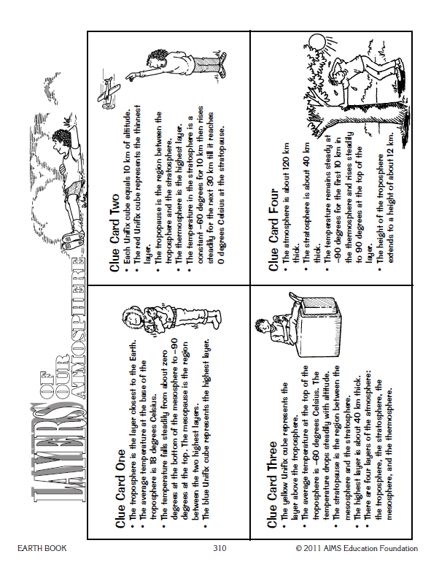

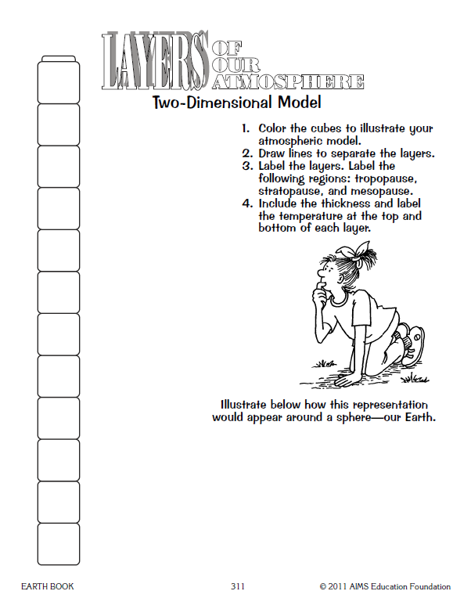
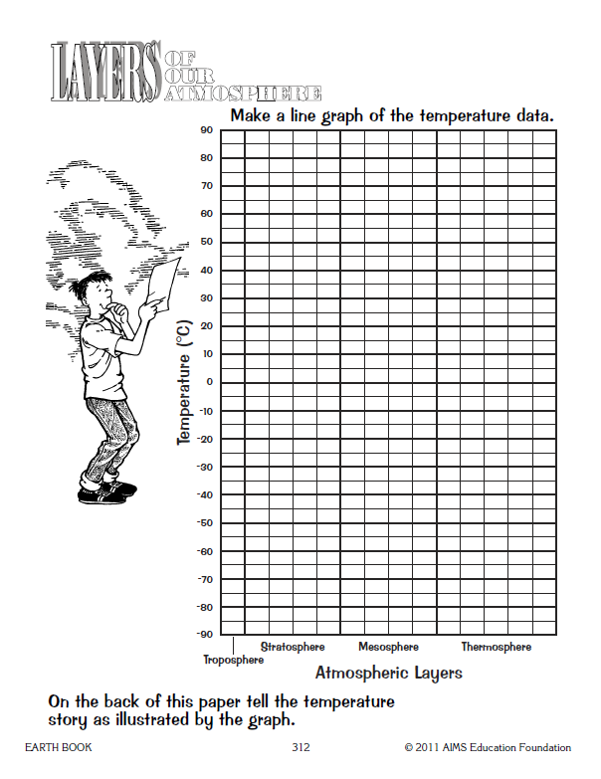

Follow up questions: Layers of the Atmosphere.
- What are the 4 layers of the atmosphere?

_______________________________________________________________________

- What are the 3 regions between the layers called?

_______________________________________________________________________

- Which layer has the coldest temperature? __________________________________________

- Which layer has the warmest temperature? _________________________________________

- Describe the pattern shown by the graph, how can this help you remember how temperature behaves in each layer? ___________________________________________________________________

_______________________________________________________________________

_______________________________________________________________________

- Large airplanes generally travel in the stratosphere, make an inference about why you think they do.

_______________________________________________________________________

_______________________________________________________________________

- Write the temperature story that is illustrated by the graph. (Describe in 5-7 sentences what this graph is demonstrating. Please include temperatures and distances.

_______________________________________________________________________

_______________________________________________________________________

_______________________________________________________________________

_______________________________________________________________________

_______________________________________________________________________

_______________________________________________________________________

_______________________________________________________________________

_______________________________________________________________________

