Objective 1: I can __________________________________________________________________
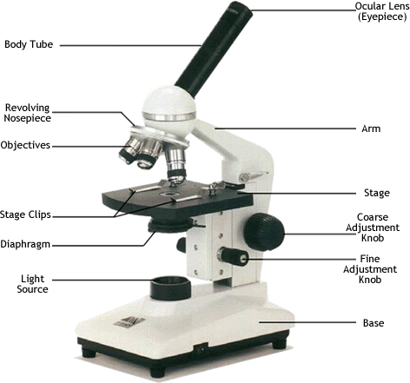

Microscope:
- This part of the microscope holds the slide in place __________________________________

- This part of the microscope controls the amount of light ____________________________________

- This part of the microscope holds the slide _______________________________

- When carrying a a microscope you carry it by the __________________ and the __________________ and hold it __________________________ to your body

Objective 2: I can follow the steps to ____________________________________________________________

- Always observe using the ______________________________ POWER objective first.

- Focus using the ______________________ ADJUSTMENT KNOB to bring the object into focus. Bring the object into sharp focus by using the fine adjustment knob.This is ONLY USED ON __________________ AND ______________________ POWER
- Focus, and then move to a higher power objective, if needed.

- Use only the ____________________ADJUSTMENT KNOB when using the HIGHEST (longest) POWER OBJECTIVE.
- Keep both eyes open to reduce eyestrain.
- Determine total magnification of the object by multiplying the power of the ocular (10x) the power by the power of the objective.
Total Magnification of Each power

LOW : Eyepiece 10x x low power 4x = ____________________

MED : Eyepiece 10x x med power 10x = _____________________

HIGH: Eyepiece 10x x high power 40x = ______________________

Objective 3: I can describe the steps to making a ___________ slide.
1 – Get a clean slide and ________________________ from your teacher.

2 – Place _______________ drop of water in the middle of the slide over your specimen. Don’t use too much or the water will run off the edge and make a mess!

3 – Place the edge of the ___________________________________ on one side of the water drop.

4 - Slowly lower the cover slip on top of the drop

5 – Place the slide on the stage and view it first with the _____________________ power objective. Once you see the image, you can rotate the nosepiece to view the slide with the different objectives.

