Motion Graph Analysis Worksheet

Instructions:
- Cut out the entire graph area above along the outside solid border line.
- Make a horizontal fold across your graph near the top (under the title). The title of the graph should be folded down with the crease of your fold at exactly the 60 meter mark of the graph area.
- Now fold the title back up so it’s visible again, but now you should have a creased line along the top just above the vertical dotted lines.
- Next, carefully cut along all four vertical dotted lines up to your fold, but no more! You should have cut the graph into sections flapping freely from the top, but still attached to the title.
- Last, tape your graph into your journal along the top edge along the title. The flaps should not be taped so they can open freely.

Analysis Questions: Answer the following questions in your journal below your foldable graph.

- On your journal, underneath each flap, write down the type of motion that is occurring for each section of the graph (ie. constant velocity, positive acceleration, negative acceleration, no motion, etc.)

- Between which two letters is the rate of speed the fastest? Why?

- The least amount of distance covered occurs between which two letters?

- Identify the type of motion occurring between letters C and D? Give evidence to support your reasoning.

- During the total journey, how many total seconds pass when the object not in motion?

- Calculate the average speed between letters B and C.

- How much distance did the object cover over the entire journey?

- Calculate the average speed for the entire journey from point A to point F.

- Write a short story (3-5 sentences) that describes a situation with the motion experienced in the graph.

Motion Graph Analysis Name________________________________________ Per_____

C.
B.
A.
Distance
Time
Distance
Time
Distance

Time

F.
E.
D.
Distance
Distance

Distance

Time
Time
Time

Descriptions of Motion
- Acceleration
- Constant Speed (high rate of speed)
- Constant Speed (low rate of speed)
- Negative Acceleration (deceleration)
- No Motion (stopped)
- Moving Backwards (constant velocity in reverse)

Graph A matches description ______ because _____________________________________________________________________.
Graph B matches description ______ because _____________________________________________________________________.
Graph C matches description ______ because _____________________________________________________________________.
Graph D matches description ______ because _____________________________________________________________________.
Graph E matches description ______ because _____________________________________________________________________.
Graph F matches description ______ because _____________________________________________________________________.

Motion Graphs - Part 2
B.
Speed
Time
Time
Speed
A.

Time
Speed
D.
C.
Speed
Time

Descriptions of Motion

- No Motion (stopped)
- Constant Speed
- Acceleration
- Negative Acceleration (deceleration)

Graph A matches description ______________________
Graph B matches description ______________________
Graph C matches description ______________________
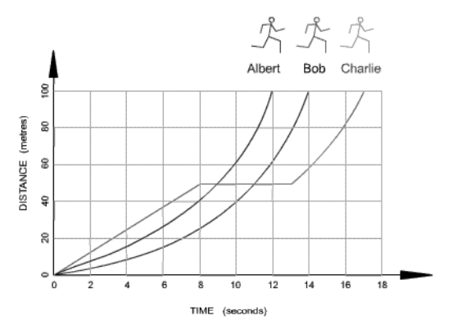
Graph D matches description _____________________
Use the graph to the right to answer the questions below.

Which runner won the race? ___________________________
Which runner stopped for a break? ______________________
How long was the stop? ______________________

Calculate each racer’s average speed over the race.
Albert - _____________
Bob - ______________
Charlie - _____________

