- Video Notes # 4 Speed/Velocity & Energy Transfer

- Objective 11: I can describe speed and velocity and calculate speed and velocity

- ___________________________: a measure of the distance covered over a period of time

- ___________________________: a measure of the distance covered in a specific __________________________ over a period of time
- Velocity = distance + direction
----------------------
time
- Speed = distance
--------------
time

A distance-time graph shows the speed of an object

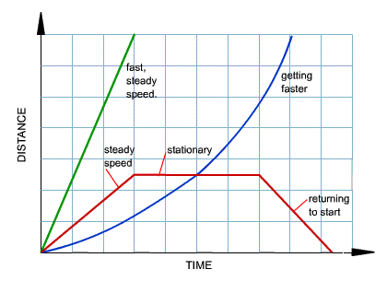
A speed-time graph shows how an object's speed changes over time.
- 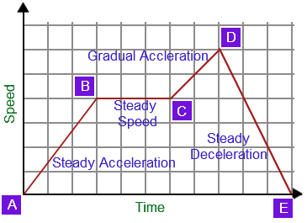

Objective 12: I can describe law of conservation of energy

- ____________________________________________Energy can neither be created nor destroyed. Energy changes from one form to another.

- The ________________________________________________________________________________________________

Objective 13: I can describe the different types of energy.

_____________________________________: Anything that has the ability to make matter move or change.

___________________________________________________________________: Energy can neither be created nor destroyed. Energy changes from one form to another. The total energy of an object never changes.

____________________________________________ : Energy that is stored in a system. It is energy that can be released to become kinetic or another form of energy.

____________________________________________________________ : The energy an object has because of its motion.
- Kinetic energy depends upon the mass and velocity of an object.

___________________________________________________ : The energy an object has because of its motion or position
- Example: wind up toys, pogo sticks. Wind power uses mechanical energy to help create electricity

_____________________________________________:Energy caused by the movement of charged particles (Electrons).
- It is easily transported through power lines and can be converted to other forms of energy

_____________________________________________ : Energy that is available for release from chemical reactions.

______________________________________________ : Energy that is stored in the nucleus of an atom.

_____________________________________________ : Energy that comes from sources that do not pollute the earth
Other types of energy
- Heat (thermal)
- Light (radiant)
- Sound

Objective 14: I can describe how energy is transferred from one form to another
__________________________________________________: The process of changing energy from one form to another

- Energy ________________________________ be created or destroyed!!!!!
- Energy changes forms….all the energy available is already here on Earth.
Examples:
- Eating food gives our body __________________________________ energy our bodies change that food into

________________________________________ energy when we move our body

- Charging our cell phone starts with ________________________________________ and changes form into

______________________________________ energy that is stored in the form of a battery.

