Animal cell and Plant Cell Organelles
Organelles common to all Eukaryotic cells (Protists, Animal cells, and Plant cells)
- ________________________________
- ________________________________
- ________________________________
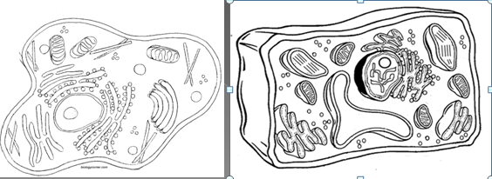
Objective 10: I can describe the _____ of an Animal cell and a Plant cell.
- Animal cells: are __________________________ shaped
- Plant cells: are _____________________________ shaped

Objective 11: I can identify and explain the ________________________ in Plant Cell and Animal cells
- Vacuoles
Function: __________________________________________
- Animal cells have _____________________small vacuoles,
- Plant Cells have one_______________ large vacuole

- Cell Membrane
Function: _______________________________________ of the cell and movement of materials in and out of the cell.

- Nucleus/Nucleolus
Nucleus function: _____________________________ of the cell, contains chromosomes which control cell growth and reproduction
Nucleolus function: ____________________________________
- Golgi Body (Golgi Apparatus)
Function: _____________________________ and materials from the endoplasmic reticulum and __________________ ____________________________________________ of the cell or outside of the cell.
- Mitochondria

Function: site of cellular respiration which ___________________________________ for the cell. The cells “power house”
- Ribosomes – free or bound
Function: makes proteins
- Endoplasmic Reticulum
- Rough and Smooth function: ___________________________ throughout the cell
- Rough endoplasmic reticulum has_________________ attached.
- ER (Endoplasmic Reticulum) is located near the ____________

- Lysosomes – Animal cells ONLY
Function: __________________________
- Contains enzymes that break down the food for the mitochondria
- Digests old cell parts

- Chloroplasts – Plant Cells ONLY
Function: Site of _______________________________ – ____________________ for the cell.

- Cell Wall – Plant Cells ONLY
Function: ______________________________ of the cell and helps the cell keep its shape.

Objective 12: I can ___________________________________ Animal and Plant Cells

Plant Cell Only Found in Both cells Animal Cell Only

