Protist Organelle Video Notes

Objective 9: I can __________________________________________________________________________________
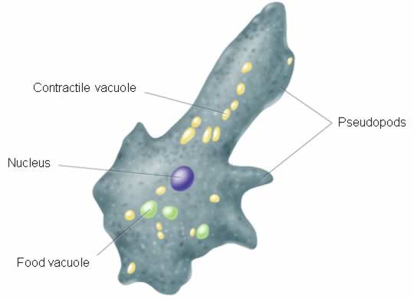
Paramecium
Amoeba
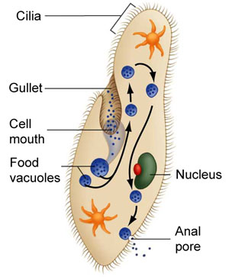

.
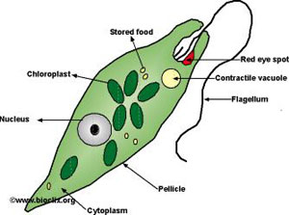
Euglena

Volvox
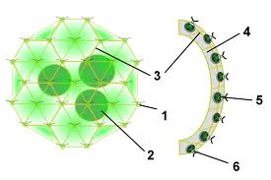

Hollow ball of individual cells

Daughter Colony

Each algae cell has 2 flagella

- Cytoplasm: the gel like substance that ______________________ ___________________ to allow other organelles to move around

- _____________________________________: the movement of cytoplasm inside of the cell which aids in movement

- Contractile Vacuole: a structure that _______________________ ________________________________ from the cell

- _________________________________: long whip like tail used for locomotion (movement)

- __________________----------: a thin wall that supports the cell membrane of some protists like euglena and paramecium

- Cilia: ___________________ that move in rhythm and are used for ____________________ (movement)

- _______________________________: false feet used for locomotion (movement) of amoebae

- _____________________: the _______________ of the cell – where DNA is stored – it controls all processes of the cell

- Chloroplasts: the site where _______________________ occurs – turns sunlight into sugar or food for the cell

- ______________________________: canal of the paramecium used to ingest nutrients.

- _______________Vacuole: area where __________________ occurs

- Red Eye Spot: helps the euglena to _______________________

