Name the Protist | What Organelles are Present? | How does it move? | How does it get food? | Unicellular or multicellular | Other Special features
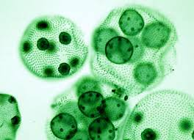
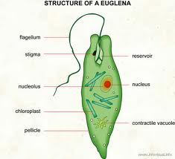
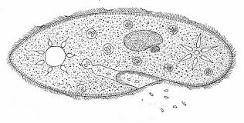
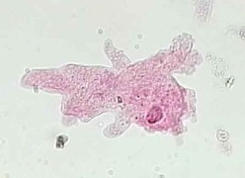
Name:__________________________________ Period:__________
- On the back color all cytoplasm Yellow 2. Color all Chloroplast green 3. Color all nucleus and Macronucleus Blue, color the micronucleus pink
4. Color all cilia and flagella black 5. Color all contractile vacuole orange 6. Color all food vacuole brown 7. Color the red eyespot red 8. Color the whole volvox colony in green 9. Color all cell membrane purple

