Video Notes: Introduction to Protists Obj 4-8

Objective 4: I can describe __________________
- Protists are a kingdom of living organisms that ___________________________________be classified as animals, plants, or fungus.
- ________________________________ – they contain a nucleus
- Can be _____________________________________(composed of only one cell) or __________________________(composed of many cells)
- Can be ____________________________________, _________________________________, _________________________________
- Live in ____________________________________ environments
- If you look at a drop of pond water under a microscope, all the "little creatures" you see swimming around are ________________________________
Objective 5: I can describe __________________________________ protists
Plant-like protists:
- Contain ___________________________________
- are ____________________________________ –they make their own food.
- Examples:
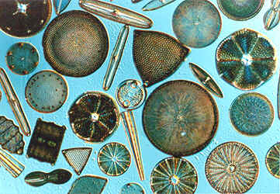
  - ______________________________: eukaryotic plant like protists that can be unicellular or multicellular, contain chlorophyll and provide over HALF of the worlds oxygen supply and is the base of the food chain(Red Algae, Brown Algae, Green Algae)
  - _____________________________: unicellular group of algae that come in a variety of shapes and sizes and contain ______________________in their cell walls.
  - Diatoms can be found in your _______________________________________

Objective 6: I can describe ____________________________________ protists
- Animal-like protists: ________________________
- _________________________– can not make their own food
- digest their food in ________________________
- Protozoans are grouped according to how they __________________
  - The word protozoa means ___________________________________ They are so named because many species behave like tiny animals—specifically, they hunt and gather other microbes as food.
3 groups of Animal-Like Protists:
- Amoebae(plural for amoeba)
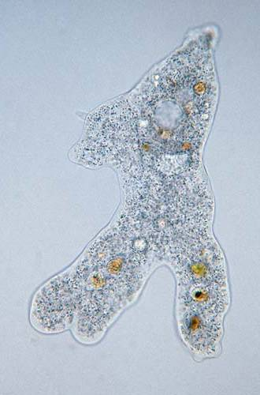
  - _______________________________________________– a unicellular life form chracterized by an irregular shape and moves using _______________________________
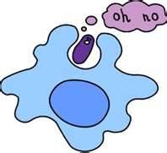

  - They engulf food as they go through a process called _________________________________________ (the cellular process of _____________________ solid particles by reshaping the cell membrane.)
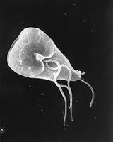
- ____________________________________ move by a tail like structure called a _____________________ which is attached to the outer membrane used for locomotion
  - generally the _________________________of the protozoa
  - have one or several _________________, ____________________________ projections called flagella poking out of their cells.
  - Flagellates use their ____________________________________ for locomotion.

Ciliates: move by tiny _______________________________________ structures used for locomotion
  - covered with hair-like projections called cilia and they eat the other two types of ___________________________________as well as bacteria.
  - Ciliates are found in every________________________ (water) habitat.
  - Examples:
    - ___________________________: a group of unicellular protozoa which mainly move by the use of cilia.
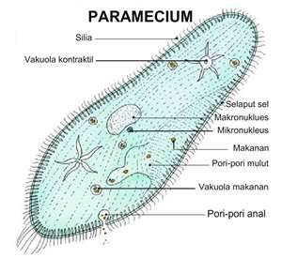

Objective 7: I can describe ________________________________ protists:

- Are _______________________________ (can NOT produce their own food)
- Many have ________________________ and are able to move at some point in their lives.
  - Examples: _____________________molds, ____________________ molds, _____________________molds
  - _________________________________ – a fungus like protist that reproduces by the use of spores
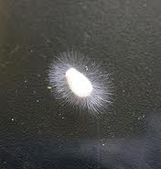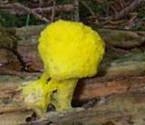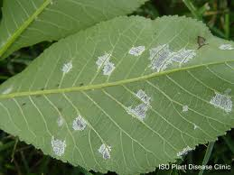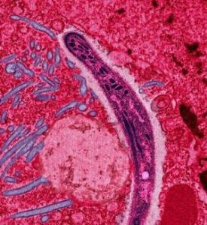
Water Mold Slime Mold Downy Mold Sporazoa

Objective 8: I can describe ____________________Protists:
- __________________________________: are both plant-like and animal-like.
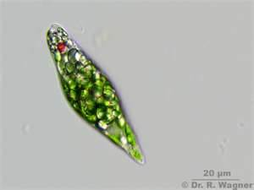
  - Euglenas are__________________________________________since they contain chlorophyll and can make food from sunlight and
  - Euglenas are also ____________________________________since they
ingest food from surrounding water.

  - Have a __________________________________________ which is used to detect light.
- ___________________________________:
  - A ___________________________________ type of green algae that forms spherical _____________________ of up to 50,000 flagellated cells
  - live in a variety of ____________________________habitats.
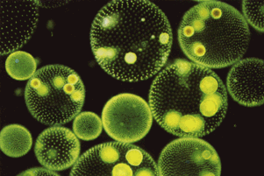
  - (A bunch of unicellular algae form a hollow ball colony together…a volvox is not multicellular!)

