Name______________________ Period________
The Keys to success of the Science Final Exam!
7.P.1.1 – Explain how the motion of an object can be described by its positon, direction and speed compared to something else.
- What is Newton’s first law and what are some ways we experience it in real life?

- What equation represents Newton’s second law?

- What is Newton’s 3rd law give some everyday examples?

- What is reference point?

- How does reference point help you to determine if something is in motion?

- How does force affect the acceleration of an object?

- How does mass affect the acceleration of an object?

- What is the amount of force needed to accelerate a 15kg object by 3m/s^{2.} (Show your work including formula)

- An object has a mass of 18kg. A force is applied to this object and causes it to accelerate at a rate of 3.5 m/s^{2.} . Calculate the force that was applied to this object. (Show work including formula)

7.P.1.3 – I can use a graph to describe & interpret the motion of an object.
10. Insert all that follow on the graph below. 1. Place the distance on the right axis, time on the right axis, label constant speed (Green), returning to start, no motion (red), Faster constant speed (blue), Slower constant speed (Orange)

- On the speed time graph below label the following points. Place speed on the right axis, time on the right axis, label constant speed (green), increasing speed (Blue), decreasing speed (orange), no motion(Red)

- A small robot can travel a distance of 32.5 meters in 13 seconds. What is the average speed of the small robot? (Show your work, include the formula)

- A truck travels between two cities according to the distance-time graph shown below. What is the truck's average speed for the first hour? What is the truck's average speed for the entire trip?

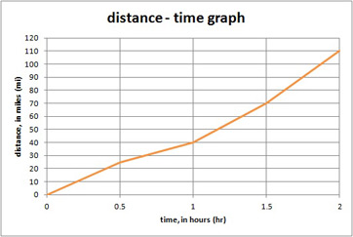

7.P.1.2 – Explain the effects of balanced and unbalanced forces acting on an object
14. How does a magnetic force affect an object?

15. In the box below calculate the net f0rce and draw an arrow to show the direction that the couch will go in. The arrow must reflect the size and direction on the force.
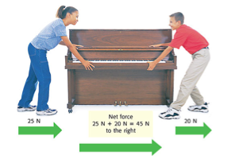

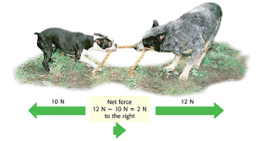
16. In the box below draw an arrow to show the size and direction of the net force between the two dogs.

17. Which way will these boxes go?

7.P.2.1 – Explain how kinetic and potential energy contribute to mechanical energy of an object
18. A sky diver ready to jump out of a plane is a great example of how mechanical energy can be transformed from one type to the next. What type of energy does she have at each point during her dive.
a. Standing at the edge of the airplane waiting to jump ______________________________________
b. As she is moving swiftly through the air approaching ground ________________________________
c. As she finally lands and is now on the ground ___________________________________________
d. What is the difference in her energy at A and C_________________________________________?
7.P.2.2 – Explain how energy can be transformed from one form to another
19. The law of conservation of energy states that energy______________________________________
____________________________________________________________________________
20. How do plants help to transform energy _____________________________________________
___________________________________________________________________________________________________________
21. The purpose of a nuclear power plant is to transform nuclear energy into electricity. This is done in steps starting with a nuclear reaction which generates heat to produce steam. The steam in turn is used to turn a generator which finally produces electricity. Draw a flow chart to include the 4 energy transformations that occur.

22. What is a circuit?

23. What are the 3 main parts of a circuit?

24. Draw a simple circuit?

25. What is the purpose of a switch in a circuit?

26. What is work and how do we calculate it?

27. A 100N of force is applied to move a box 5m. How much work is being done on the box?

7.P.2.4 – Explain how simple machines such as inclined planes, pulleys, levers, and wheel and axles are used to create mechanical advantage and increase efficiency.
28. Simple machines may do one or more of the following to make work easier fill out the table below to show how each simple machine works to make work easier
 | Lever | Wedge | Screw | Wheel and Axel | Incline plane | gears
Change the direction of force
Transfers the force
Increase the size of the force
Increase the distance of the force

29. What is the efficiency of a simple machine and why?

30. Use the data set below to create a distance time graph. Graph must have a title, axes must be labeled with variable and units and the graph must have a scale that fits the data.
Distance vs. Time
Time (s) | Distance (m)
0 | 0
2 | 5
4 | 5
6 | 10
8 | 15

I understand everything in this study guide and feel confident about the exam!

I am still struggling with ____________________________________________________________________________________________________________________________________________________________________________________________________________________________________________________________________________________________________________________________________________________________________________________________________________________________________________________________________________________________________________________

