SPEED (VELOCITY) – TIME Graphs
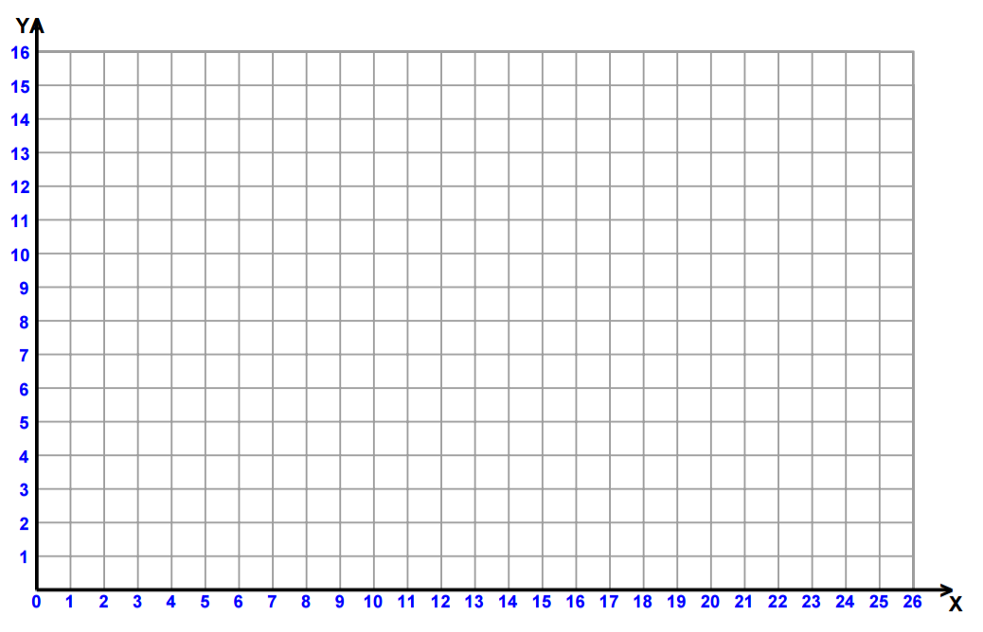

SPEED =
DISTANCE =
TIME =

A SPEED-TIME GRAPH SHOWS: _____________________________________________________________ _________________________________________________________________________________________
A DIAGONAL (NEGATIVE SLOPE) line means…

A DIAGONAL (POSITIVE SLOPE) line means…

A STRAIGHT HORIZONTAL line means…

tells us how the speed of an object changes over time

A STRAIGHT horizontal line means that speed is constant. It is not changing over time

