Stages of development timeline-Homework Due thusday 5/12
Use your notes and any other resource you like to create a timeline on the stages of development before and after birth. Start and Egg meeting sperm and end at adulthood (or death, If your want). State approximately how long each stage lasts and state any special developments that happens at each stage. This is a graded assignment Due on Thursday. Here are a few pics to help you get started, you can use others or draw if you want.
Please use the timeline strip issued in class to complete this.

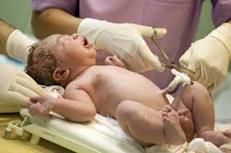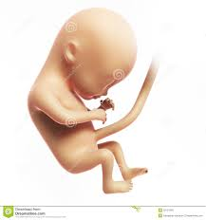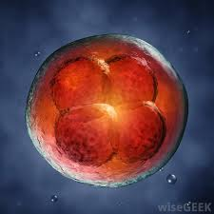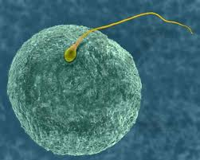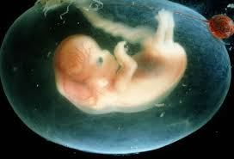
Rubric
All the stages listed | 4 points
The length of each stage | 4 points
Brief description of the stage | 8 points
Special feature of each stage | 4 points
Appropriate pictures/illustrations/Neatness | 5 points
Total | 25 points

