**Station 3: Match and Label**

**Animal Cell**

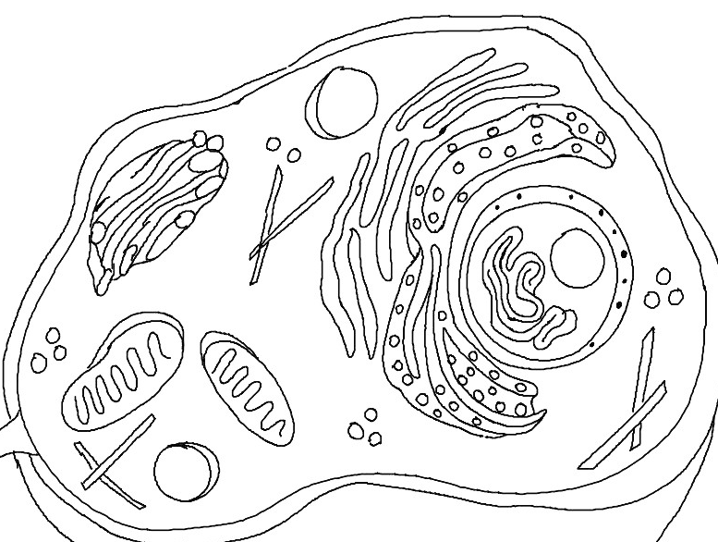

**Plant Cell**

