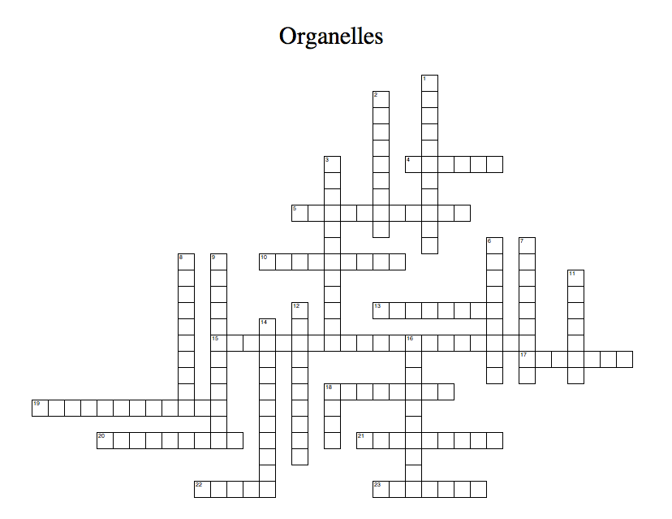
Station 8: Cells Crossword

ACROSS
4 | a protist that lives in a colony
5 | an organelle found in animal like protists that is used for digesting food
10 | the thick jelly like substance that fills the interior of the cell.
13 | the tough outer membrane of some protists like a euglena and paramecium that help the cell keep its shape
15 | the transportation system of the cell
17 | a protist that is both animal like and plant like
18 | an organelle found only in plant cells that is used for protection, support, and to keep the cell shape rigid.
19 | the organelle that provides energy for the cell
20 | an organelle found in animal cells used for digesting food
21 | a protist that can make its own food
22 | another name for plant like protists
23 | the organelle that controls cell function and reproduction
DOWN
1 | a protist that must hunt or gather its food
2 | another name for animal like protists
3 | an organelle found in plants and plant like protists that convert sunlight into glucose
6 | the organelle responsible for making ribosomes
7 | an organelle that makes proteins
8 | another name for fungus like protists
9 | the organelle responsible for determining what can come in and out of the cell. It also provides protection and support of the cell
11 | storage for water, food, wages, and enzymes
12 | The organelle that sends and receives proteins
14 | a vacuole only found in protists that removes excess water from the cell
16 | all cells that have a nucleus
18 | the smallest living thing

