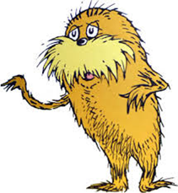
Name_________________________ Date____________________ Period__________________
The Lorax- Pre-Read, written by Dr. Seuss (1971)

Humans need to cut trees to make things like paper or houses. | Agree/Disagree
Humans always protect the environment. | Agree/Disagree
We need trees to give us oxygen and remove carbon dioxide from the earth. | Agree/Disagree
We need to have a plan to replace trees if we cut trees down. | Agree/Disagree

Brainstorming Ideas: “When I think of earth’s natural resources, I think”:
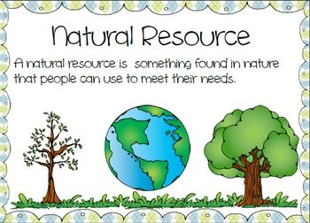
1. 5.
2. 6.
3. 7.
4. 8.

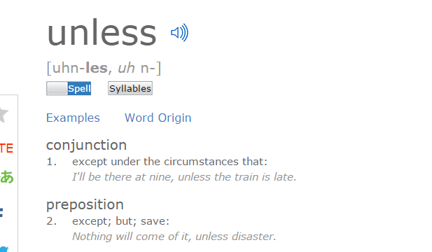
Looking at the definition of “UNLESS”, how do you think it relates to our topic of stewardship?
____________________________________________________
____________________________________________________
____________________________________________________

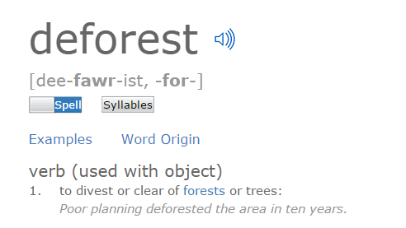
Looking at the definition of “DEFOREST”, how do you think it relates to our topic of stewardship? ____________________________________________________
_____________________________________________________________
_____________________________________________________________

Important Vocabulary Terms
Lorax | Thneed
Truffala Trees | Smog
Once-ler | Gluppity-Glupp
Swomee-Swans | Schloppity-Schlopp.
Bar-ba-loot | Humming-Fish

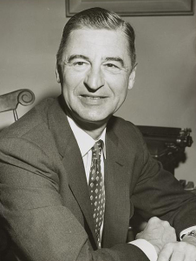
“The Lorax is a fairly grim tale compared to Green Eggs and Ham or The Cat in the Hat, for sure. But it reflects the era in which it was written. In 1971, when the book was released, the United States was embroiled in environmental issues left over from the 1960s. The deforestation of the Pacific Northwest was chief among them; logging companies were cutting down trees at alarming rates. Needless to say, the logging industry was not happy about The Lorax. The book was banned from many schools and libraries near thriving timber communities. Timber industry groups even sponsored a rebuttal book, called The Truax, which helped kids understand the necessity of harvesting timber. The Lorax, the video was released in 1972 as an animated musical television special produced by DePatie-Freleng Enterprises. It first aired on CBS on February 14, 1972 (Valentine's Day).”

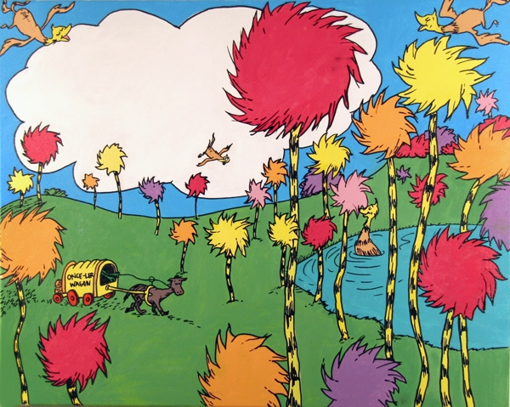

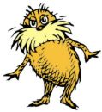
LORAX MOVIE QUESTIONS
Directions: Watch the short animated film, "The Lorax" and answer the following questions in DECSRIPTIVE PHRASES or SHORT SENTENCES based on the factual information and your interpretation.
NOTE: Most questions progress in sequence with the film; however, some questions are also cumulative based on information from several points in the film.

- The Once-ler describes a "glorious place." Identify and briefly describe four living components of the "glorious place."

- What was the Lorax? Explain his role.

- Why was the thneed a marketable and profitable product? List four products it is made into.

- Identify and briefly describe three pieces of technology developed by the Once-ler to upgrade his thneed industry.

- Most environmental problems result from a "domino effect" begun by a single action or activity. Select three of the following environmental issues below observed in the "glorious place" and relate them to the development of the thneed.
Energy Consumption | Waste Disposal & Management | Human Population Explosion | Pollution | Deforestation | Endangered or Threatened Species
- What is an unless?

- A "Thneed" is defined as a fine thing that everyone thinks they need (but probably really does not). What are some examples of thneeds - things that we think we need, but could do quite well without?
(3 examples)

- The Lorax spoke for trees "for the trees have no tongues". What would you choose to speak for, and what would you say? (MINIUMUM of 6 sentences)

- Describe what you can do to help preserve natural resources? (MINIMUM of 3-5 sentences)

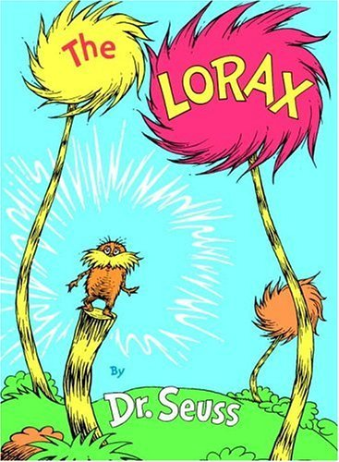

Name_________________________________ Pd:_____ Date_____________________
The Lorax Characters
Directions: As you view the movie, The Lorax, record information about the main characters.
Character | Habitat  Where do they live and what do they eat?  house, trees, pond, or forest | Describe the Character  Is it -human, animal, or plant? What are its color, shape, and size? | Characters Thinking about Saving the Environment-  To preserve the environment or does not care at all  - Use CONTEXT CLUES from the video
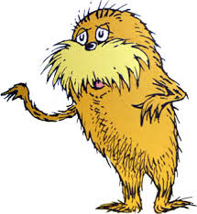
The Lorax
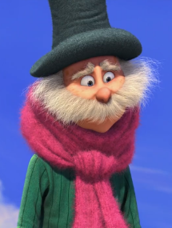
The Once-ler

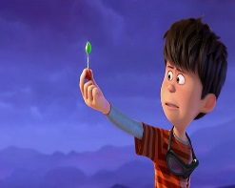
Ted -The Boy

Character | Habitat  Where do they live and what do they eat?  house, trees, pond, or forest | Describe the Character  Is it -human, animal, or plant? What are its color, shape, and size? | Characters Thinking about Saving the Environment-  To preserve the environment or does not care at all  Use CONTEXT CLUES from the video
Bar-ba loot
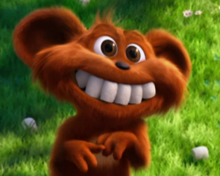
Humming-Fish
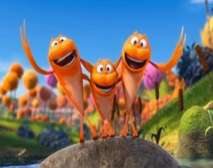
Swomee-Swans
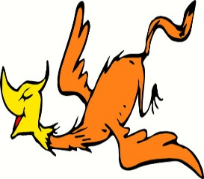
Truffala-Tree

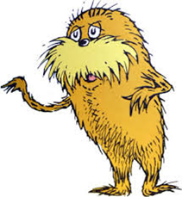
Name______________________ Date _____________________ Period_____________________
The Lorax – Post-Viewing Questions
Humans need to cut trees to make things like paper or houses. | Agree/Disagree
Humans always protect the environment. | Agree/Disagree
We need trees to give us oxygen and remove carbon dioxide from the earth. | Agree/Disagree
We need to have a plan to replace trees if we cut trees down. | Agree/Disagree

CHOOSE 1 of the following assignment options.
Mind Mirror
- You will create a Mind Mirror for one of the following characters: the Lorax, Bar-Ba-Loots, Humming Fish, the Once-ler, or Ted- the Boy.
- The Mind Mirror needs to contain 5 components:
  - 3 characteristics/traits for survival for the selected character.
  - 3 key terms/phrases about the book and/or video that summarize the story.
  - Drawing (Mind Mirror) with symbols for eyes & a statement for the mouth.
    - Symbols for eyes represent the point of view of the character
    - Statement for the mouth represents the point of view of the character and what they would “speak” for.
  - Written justification of your Mind Mirror final drawing
    - Justify your characteristics/traits, symbols, and statement
    - This should be a minimum of 3 paragraphs (1 for each component)
  - Thinking about the 1972 version of The Lorax, connect how the topics of this short animated film/book relate to issues of air quality & stewardship today.
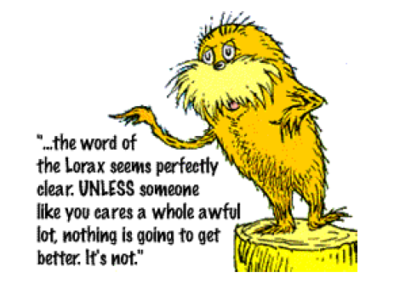
    - Create a Mind Map that connects the film to issues of today. REMEMBER to use context clues from the film. It would be a great idea to think about some of the information you gathered from the Air Quality Stations!!!
Epilogue
That was long, long ago, but each day since that day I’ve sat here and worried and worried away. Through the years, while my buildings have fallen apart, I’ve worried about it with all of my heart. “But now,” says the Once-ler, “Now that you're here, the word of the Lorax seems perfectly clear. UNLESS someone like you cares a whole awful lot, nothing is going to get better. It’s not.

The definition of an epilogue is a concluding part added to a literary work, such as a novel

Create an epilogue to the Lorax’s cautionary tale. You may write a google doc, a Prezi, slide presentation, an iMovie or other approved form of presentation to give an update to the Lorax’s story. Your epilogue must answer the following questions:
- What happened to the Lorax and the Oncler? What happened between Ted and Audrey?
- What happened to the Thneedville ecosystem? What happened to the truffula trees? Did the barbaloots and fish return?
- Did Thneedville learn from the Lorax’s story? If so, how did they change their behavior? How did this affect their ecosystem?
- Written justification for your epilogue (why did you decide the fate of each character, ecosystem, animal, plant, etc…). This should well thought, detailed, and cite context clues from the film.
- Thinking about the 1972 version of The Lorax, connect how the topics of this short animated film/book relate to issues of air quality & stewardship today.
    - Create a Mind Map that connects the film to issues of today. REMEMBER to use context clues from the film. It would be a great idea to think about some of the information you gathered from the Air Quality Stations!!!
The Lorax – Rubric
CRITERIA | POINTS
MIND MIRROR OPTION  For your chosen character…  - 3 characteristics/traits for survival for the selected character. (in drawing)  - 3 key terms/phrases about the book and/or video that summarize the story. (in drawing)  - Drawing (Mind Mirror) with symbols for eyes & a statement for the mouth.  - Symbols for eyes represent the point of view of the character  - Statement for the mouth represents the point of view of the character and what they would “speak” for.  - Written justification of your Mind Mirror final drawing  - Justify your characteristics/traits, symbols, and statement  - This should be a minimum of 3 paragraphs (1 for each component) | ___/25  ___/20  ___/30
EPILOGUE OPTION  Must contain…  - What happened to the Lorax and the Oncler? What happened between Ted and Audrey?  - What happened to the Thneedville ecosystem? What happened to the truffula trees? Did the barbaloots and fish return?  - Did Thneedville learn from the Lorax’s story? If so, how did they change their behavior? How did this affect their ecosystem?  - Written justification for your epilogue (why did you decide the fate of each character, ecosystem, animal, plant, etc…). This should well thought, detailed, and cite context clues from the film. (minimum 2 paragraphs) | ___/45  ___/30
MIND MIRROR & EPILOGUE OPTIONS  Thinking about the 1972 version of The Lorax, connect how the topics of this short animated film/book relate to issues of air quality & stewardship today.  - Create a Mind Map that connects the film to issues of today.  - Uses context clues from the film.  - Use information from Air Quality Stations | ___/25
TOTAL | ____/100
Teacher Comments:

