Name:__________________________________ Pd:_______ Date:___________________
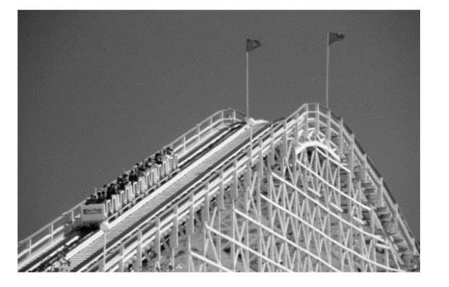
Energy Review
- There are many forms of energy. All energy falls into one of two categories; either potential or kinetic energy. A roller coaster at different points along its path, involves kinetic energy being transformed into potential energy.

Using the law of conservation of energy, explain in detail how the kinetic energy is transformed into potential energy on a rollercoaster. Be sure to explain the differences and similarities between kinetic and potential energy in your response.

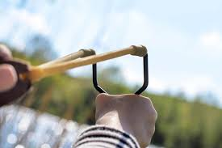
- A student uses a slingshot to launch a rock through the air. Describe the changes in potential and kinetic energy of the rock as the student pulls it back in the sling and releases it, and then as the rock flies upward through the air, curves downward, and finally hits the ground. Specify what form(s) of energy the rock has at each point in its journey. Create a diagram to support your answer.

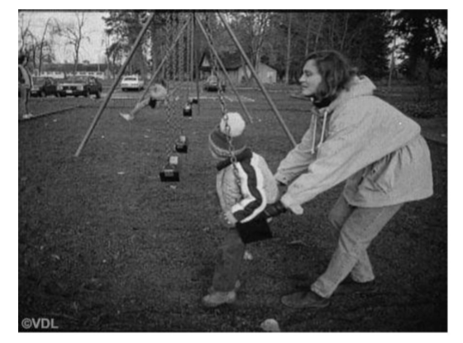
- Potential energy is energy that is stored and ready to be released. Look at the image to the right and identify when the child in the swing has potential energy. Justify why this is the case at the points you identify.

- Where is the kinetic energy greatest on the course of the roller coaster illustrated below? Where is the potential energy greatest?
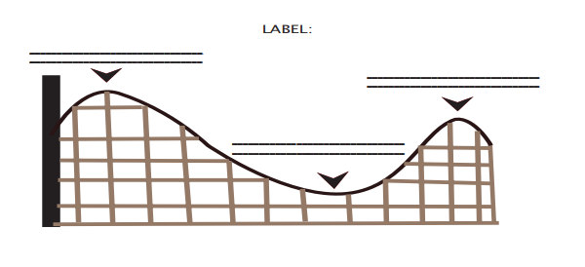
- Why is the first hill on all the roller coasters always the highest one?

- Classify the following as a type of potential energy or kinetic energy (use the letters K or P).
A bicyclist pedaling up a hill __________ | An archer with his bow drawn __________
A volleyball player spiking a ball__________ | A baseball thrown to second base__________
The chemical bonds in sugar__________ | The wind blowing through your hair__________
Walking down the street __________ | Sitting in the top of a tree __________
A bowling ball rolling down the alley________ | A bowling ball sitting on the rack __________

- What examples can you find in your home that are examples of kinetic and potential energy (name two for each type of energy)?
  - Kinetic: _______________________________________________________
  - Kinetic: _______________________________________________________
  - Potential: ______________________________________________________
  - Potential: ______________________________________________________

- A boy pulls a wagon with a force of 6N east as another boy pushes it with a force of 4N east. What is the net force? Create a diagram to support your answer.

- Determine the net force of the object, if the forces are balanced or unbalanced, and what direction the box will move.
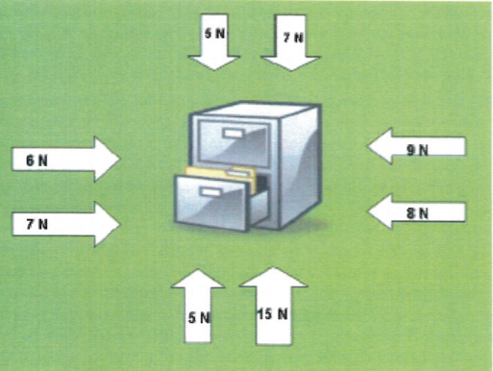
Balanced or Unbalanced?

Net Force:______________

Direction of Box:__________________

- In the rollercoaster lab, if you increased the size of the marble, and therefore its mass, how would the potential and kinetic energy change?

