Name: __________________________ Per: ___ Objectives: 7.P.2.1 and 7.P.2.2

Types of Energy, Law of Conservation and Energy Transformations
7. P.2.1 _____________ how kinetic and potential energy contribute to the mechanical energy of an object.
7. P.2.2 _____________ how energy can be transformed from one form to another (specifically potential energy and kinetic energy) using a model or a diagram of a moving object.
What is Energy?
____________ is the ability to do ________. Energy is anything that can make matter _________ or ______________.
Work is the use of _________ to move an object. The amount of work done depends on the amount of __________ exerted and the _____________ the object traveled.
Law of Conservation of Energy
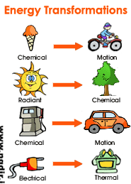
The Law of conservation of __________ states that energy ___________ be __________ nor ______________. Instead, it must be _____________ from one type to another.
Types of energy
____________________ Energy = ______________ energy
It is the energy that an object has because of its ________________ or condition. There are several types of Potential energy
1. Gravitational Potential- Energy due to your height above ground. This Dog has ______________ Potential Energy because of his position above ground.
Elastic Potential: ___________ energy due __________________ or __________ of an _____________ object.
_______________ Energy: Energy an object has due to its _________________.
The amount of kinetic energy an object has is influenced by its _________ and ______________.
As long as it’s __________________ it has Kinetic Energy.
_____________________ + ______________________= Mechanical Energy.
Mechanical Energy due to an object’s ___________ (kinetic) or ______________ (potential). The bowling ball has ________________ energy.
When the ball strikes the pins, ______________energy is transferred to the pins and causes them to _____________!
Examples of Mechanical Energy: A rocket Launching, a swimmer swimming and A skier skiing.
Electromagnetic Energy: ________________ energy includes energy from gamma rays, XRays, _______________ rays, _________ light, _________________ rays, ___________ and __________ bands.
Electrical Energy: Energy caused by the movement of _________________. Easily transported through ________________ lines and converted into ________ forms of energy.
Chemical Energy: A form of ____________ Energy that is available for release from chemical ______________. The chemical __________ in a matchstick store energy that is __________________ into ______________ (Heat) energy when the match is struck.
Examples of Chemical Energy, coal, any form of food, batteries.
Thermal Energy= ________________ energy. The heat energy of an object determines how active its atoms are.
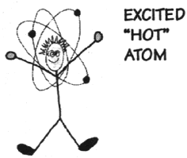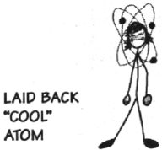

A _______ object is one whose atoms and molecules are excited and show rapid _____________. A _______________ object's molecules and atoms will show __________ movement.
QUIZ TIME!
What type of energy cooks food in a microwave oven? ________________________________
What type of energy is the spinning plate inside of a microwave oven? _____________________
Electrical energy is transported to your house through power lines. When you plug an electric fan to a power outlet, electrical energy is transformed into what type of energy? __________________________
What energy transformation occurs when an electric lamp is turned on? ___________________ Energy is converted to ______________________.
What types of energy are shown below?
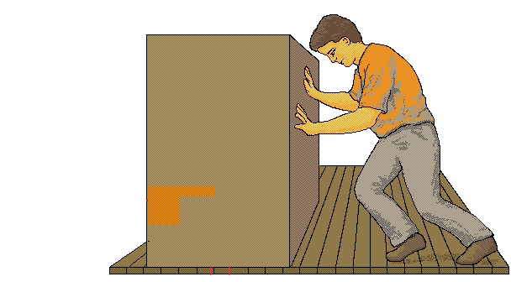
___________________________ ________________________ ________________ (Don’t forget friction)
What type of energy does the tree represent ____________________.
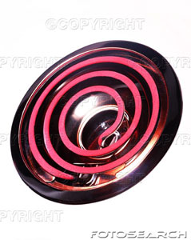
What types of energy are shown below?
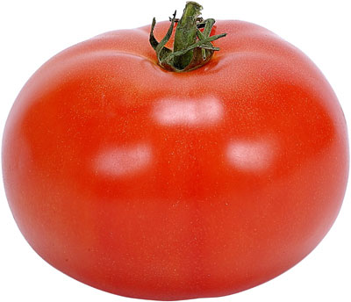
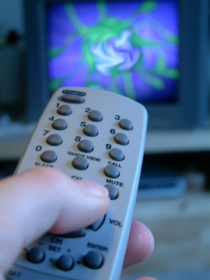

_____________________ _ _____________________ _________________________
______________________
______________________
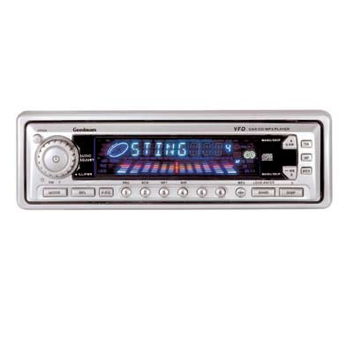
Draw a flow map showing the flow of energy transformations in a car from starting vehicle to driving. You should have 5 different types of energy.

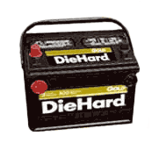
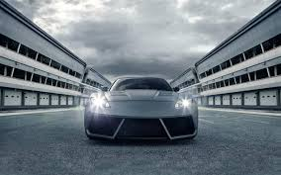
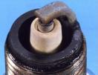
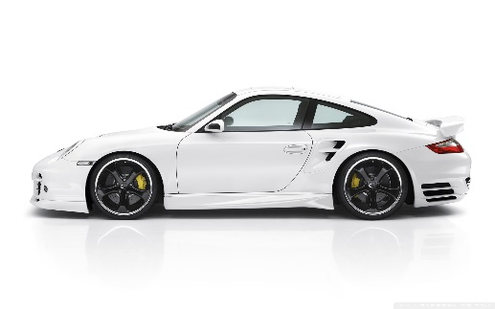

Study Jams- Energy
Watch the video and write down 3 things that it helped you to understand more clearly.
____________________________________________________________________________________________________________________________________________________________________________________________________________________________________________________________________________________

