Name_____________________________________________________________ Date______________________
Atmosphere and Weather Exam Study Guide
- What are the five steps to the water cycle?
- What does alto mean?
- What does nimbo mean?
- What are the two most abundant gases in the atmosphere?
- What is the most abundant gas in the atmosphere?
- What percentage of the atmosphere does oxygen make up?
- How does heat from the sun heat us?
- Winds are caused by uneven heating of the Earth’s surface by ________________.
- The transfer of heat from direct contact of an object and how the Earth is heated is called _____________.
- How does the Jet Stream affect weather in the Northern Hemisphere?
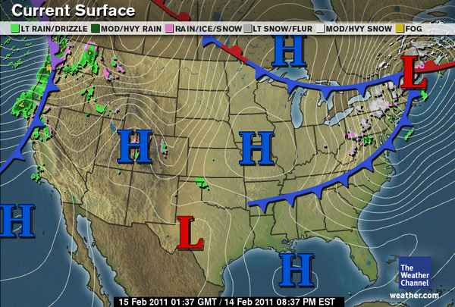
- How does the jet streams affect planes?
- How does water turn into water vapor?
- What do isobars measure?
- Based on the map to the right, what type of front is headed to Raleigh?
- What type of pressure system is over Texas? What type of weather does this bring?
- What type of pressure system is over the Gulf of Mexico, what type of weather does this bring?
- What is the Coriolis effect?
- What causes winds?
- What direction do the prevailing westerlies travel?
- How do clouds form?
- What type of clouds form at high altitudes and are made of ice crystals?
- What type of clouds blanket the sky and bring precipitation?
- What type of front will cause a thunderstorm typically?
- What is a tornado and draw a picture?

- What pressure system do hurricanes form in?
- Describe a warm front and draw a picture.

- Describe a cold front and draw a picture.

- Describe a stationary front and draw a picture.

- What does the ozone layer protect us from?
- How are the layers of the atmosphere classified?
- Which layer does weather occur in?
- What happens to density as you increase altitude?
- What happens to temperature as you increase altitude?
- What happens to air pressure as you increase altitude?
- Draw and label each weather tool and what they measure: thermometer, barometer, anemometer

- Why has weather forecasting improved in the past 10 years?
- What are the characteristics of a continental tropical air mass?
- What are the characteristics of a polar air mass?
- What are the characteristics of a maritime tropical air mass?
- What are the characteristics of a maritime polar air mass?

ON A SEPARATE SHEET OF PAPER ANSWER THE FOLLOWING QUESTIONS:
- Using the same surface area map from question 12-13, wire a detailed current and 3 day forecast for Raleigh

- Draw the layers of the atmosphere. Include thickness, temperatures, and what can be found in each layer.

- Explain how altitude affects temperature, pressure, and density.

- What is an environmental steward? Explain what you can do now and in the future to be an environmental steward, and why it is important to be an environmental steward

