Name:_______________________________ Period:_____ Due:__________
Weather Properties
Air Movement and Weather Patterns
Objective 7.E.1.3 ___________________ the relationship between the movements of _______________________________; ________________ and low pressure systems, and __________________________ boundaries to storms (including thunderstorms, hurricanes, and tornadoes) and other weather conditions that may result.
What is an Air Mass?
Air Mass- A huge body of _______________ that has similar _______________, humidity and air _______________________. Air masses usually take on the characteristics of where they ___________________.
4 types of air
___________________ originates at latitudes 60⁰ north and south and are usually _____________ air
_____________________originates at latitudes with 25⁰ of the equator and are usually ___________air
_______________________ originates over the oceans usually ________________________ air
____________________________ originates over large land masses and are usually ___________ air
We can combine the different types of air to describe air masses:
Maritime Polar = ________________________ and ______________________
Maritime tropical = _______________________ and ______________________
Continental Tropical = _____________________ and ______________________
Continental Polar = _______________________and ______________________
North American Air mass source regions

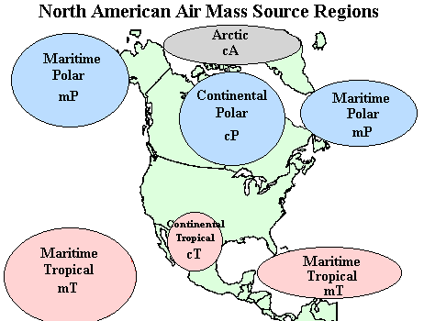
Fronts
A Front- A______________________ where two air masses _______________________.
Fronts can be identified by looking at changes in temperature, air pressure, humidity and changes in wind direction.
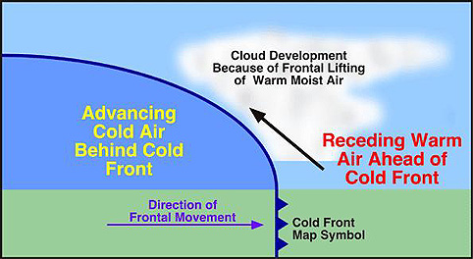
There are _________ types of fronts
Cold Front
A cold front occurs when __________ ________ comes in and ____________________ warmer air that exists. They move __________and cause fast weather changes.
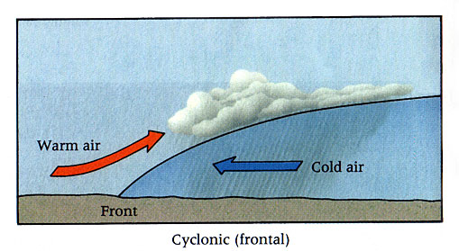
Warm Front
Warm fronts occur when a ____________ air mass ______ over a ______________ air mass. Warm fronts move ________________. It can be rainy or cloudy for __________________days.
After it passes the weather is ________________ and ______________________.

Stationary Front: When _______ air masses exist along a boundary but ________________ of them is moving. _______________________ forms at the point where they meet.
Occluded Front: Formed when _____ _____________ air masses, __________ off and __________ up a ________________ air mass. Forms __________________ and possibly precipitation.
Pressure Systems
The amount of air _________________is how much the air in the atmosphere is pushing down on the surface of the________________.
If the pressure is ____________ that means that the air is _____________ and pushing down on the earth’s surface.
Air is low
=
Lots of pressure = high pressure

If the pressure is ______________ it means the air is _______________ in the atmosphere and therefore not putting as much pressure on the surface.
Air is up high
=
Low pressure

Low Pressure Systems: Cyclones | High Pressure systems Anticyclone
A swirling center of low pressure air which forms at frontal boundaries and brings _______________, _______________ and ____________________.  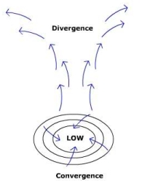 | High pressure centers of ___________ air that are formed at _________________ boundaries and is associated with ________, __________ weather.  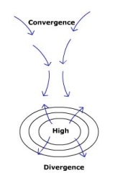

High Vs Low Pressure
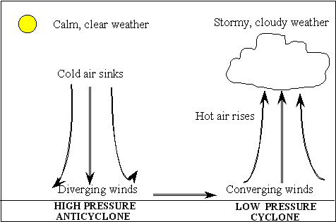
Severe Weather
Tornados
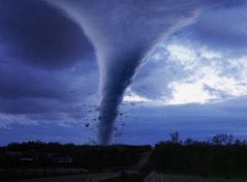
Develop in thick CUMULONIMBUS _________________.
Form when a ________________ ________________ air mass
meets a dry cold air mass – warm air is forced upwards along a
cold front to produce several thunderstorms which can turn into
tornadoes. Most damaging type of storm because they are ________________. Tornado ________________ – central US from Texas to Nebraska/Iowa – nearly 800 tornadoes form in this area every year.
Hurricanes
Characteristics: Winds over 119 km/hr, 600 km across, Form in the Atlantic, Pacific, or Indian Ocean, Strength of hurricane comes from the _____________, moist air. Hurricanes form around _________________ pressure systems over warm ________________water. As the area grows in size and in strength it forms a tropical storm followed by a _______________________ if it continues to grow.
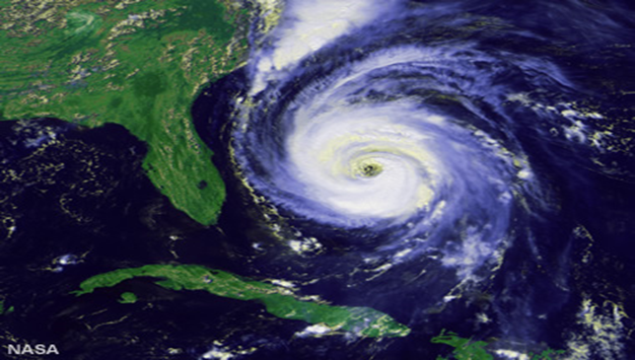

Thunderstorms
Thunderstorms form in large CUMULONIMBUS _________________, when _________ air is forced rapidly upwards along a cold front.
Characteristics: Heavy Rain/possibly hail, Strong upward and downward winds (updrafts and downdrafts), Lightning and Thunder.
Other weather conditions: Floods
Occurs when the volume of water increases in a __________________ period of time causing a body of water to overflow its channel. Flash flood- happens in a “flash”. Advance warning, dams and levees are all ___________________ measures and forms of flood control.
Droughts
_____________________ period of time with little rainfall. Typically caused by ________ weather systems that remain in place for long periods of time. Water conservation is necessary

Questions?
- What happens to the weather when a cold or warm front passes through an area?
Cold

Warm Front

- How does pressure and air mass movement affect the development of various types of storms?

- How do high and low pressure systems change the weather in an area?
High Pressure

Low Pressure

