Name _____________________________

Genetics: X Linked Genes

In fruit flies, eye color is a sex linked trait. Red is dominant to white.

1. What are the sexes and eye colors of flies with the following genotypes:

X ^{R} X ^{r} _______________ X ^{R} Y _______________
X ^{R} X ^{R} _______________ X ^{r} Y _______________

2. What are the genotypes of these flies:

white eyed, male _______________ red eyed female (heterozygous) _______________
white eyed, female _______________ red eyed, male _______________

3. Show the cross of a white eyed female X ^{r} X ^{r} with a red-eyed male X ^{R} Y .
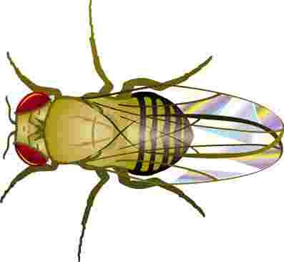

4. Show a cross between a pure red eyed female and a white eyed male.
What are the genotypes of the parents:
_______________& _______________

How many are:
white eyed, male_______________
white eyed, female _______________
red eyed, male _______________
red eyed, female _______________

5. Show the cross of a red eyed female (heterozygous) and a red eyed male. What are the genotypes of the parents?
_______________ & _______________

How many are:
white eyed, male_______________
white eyed, female _______________
Math: What if in the above cross, 100 males were produced and 200 females.
How many total red-eyed flies would there be?
____________

red eyed, male _______________ red eyed, female _______________
6. In humans, hemophilia is a sex linked trait. Females can be normal, carriers, or have the disease. Males will either have the disease or not (but they won’t ever be carriers)

= female, normal  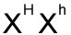= female, carrier  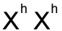 = female, hemophiliac | = male, normal  = male, hemophiliac

Show the cross of a man who has hemophilia with a woman who is a carrier.

What is the probability that their children will have the disease? _______________

7. A woman who is a carrier marries a normal man. Show the cross. What is the probability that their children will have hemophilia? What sex will a child in the family with Hemophilia be?

8. A woman who has hemophilia marries a normal man. How many of their children will have hemophilia, and what is their sex?

9. In cats, the gene for calico (multicolored) cats is codominant. Females that receive a B and an R gene have black and orange splotches on white coats. Males can only be black or orange, but never calico.
Here’s what a calico female’s genotype would look like. X ^{B} X ^{R}

Show the cross of a female calico cat with a black male?

What percentage of the kittens will be black and male? _______________
What percentage of the kittens will be calico and male? _______________
What percentage of the kittens will be calico and female? _______________

10. Show the cross of a female black cat with a male orange cat.

What percentage of the kittens will be calico and female? _______________
What color will all the male cats be? _______________

